**Update: Topiramate (Topamax) - introduction of new safety measures, including a Pregnancy Prevention Programme**

Topiramate is now contraindicated in pregnancy and in women of childbearing potential unless the conditions of a Pregnancy Prevention Programme (PPP) are fulfilled. This follows a [major safety review](https://www.gov.uk/drug-safety-update/topiramate-topamax-start-of-safety-review-triggered-by-a-study-reporting-an-increased-risk-of-neurodevelopmental-disabilities-in-children-with-prenatal-exposure) by the MHRA which concluded that the use of topiramate during pregnancy is associated with significant harm to the unborn child. Harms included a higher risk of congenital malformation, low birth weight and a potential increased risk of intellectual disability, autistic spectrum disorder and attention deficit hyperactivity disorder in children of mothers taking topiramate during pregnancy. Further information can be found in the June 2024 [MHRA Drug Safety Update](https://www.gov.uk/drug-safety-update/topiramate-topamax-introduction-of-new-safety-measures-including-a-pregnancy-prevention-programme).

The use of topiramate is now contraindicated:

* in women of childbearing potential unless the conditions of the Pregnancy Prevention Programme are fulfilled (for all indications)
* in pregnancy for prophylaxis of migraine
* in pregnancy for epilepsy unless there is no other suitable treatment

The PPP aims to ensure that women of childbearing potential:

* Are **informed of the risks of topiramate** (risk minimisation materials are available to go through with patients and include a Patient Guide for [Epilepsy](https://www.medicines.org.uk/emc/rmm/3081/Document) or [Prophylaxis of Migraine](https://www.medicines.org.uk/emc/rmm/3082/Document) to help explain the reason why there is a PPP for topiramate; there is also a Guide for Health Care Professionals for [Epilepsy](https://www.medicines.org.uk/emc/rmm/3080/Document) and [Prophylaxis of Migraine](https://www.medicines.org.uk/emc/rmm/3079/Document)).
* Are **using highly effective contraceptio**n throughout treatment without interruption and for at least 4 weeks after the last dose (topiramate is an enzyme inducer that reduces effectiveness of hormonal contraceptives and there are limited options for highly effective contraception – see point 9 of the [FSRH Clinical Guidance: Drug Interactions with Hormonal Contraception](https://www.fsrh.org/Public/Documents/ceu-clinical-guidance-drug-interactions-with-hormonal.aspx?WebsiteKey=f858b086-d221-4a83-9688-824162920b1b) for information on suitable forms of highly effective contraception).
* Complete **Annual Risk Awareness Form (ARAF)** during a consultation with a *healthcare professional* to document discussion of the risks (there are separate ARAF forms for [Epilepsy](https://www.medicines.org.uk/emc/rmm/3083/Document) and [Prophylaxis of migraine](https://www.medicines.org.uk/emc/rmm/3084/Document)). This must be done at treatment initiation *and* at annual review.

Topiramate is currently classed as TLS amber initiated on the local BNSSG formulary for epilepsy but TLS blue for prophylaxis of migraine in adults. For Children topiramate is classified as amber 3 months for both indications.

**Practice Advice for Prescribers**

**ALL women of childbearing potential CURRENTLY Prescribed Topiramate:**

* Identify all women of childbearing potential on topiramate using the **EMIS** search provided below. Alternatively, **Ardens** have also provided searches for GP practices, the report can be found in Prescribing | Alerts > Neurology See search information below.
* Ensure there is a correct **read code** indication for topiramate within the clinical record. This will be **epilepsy** or **prophylaxis of migraine** in most cases.
* **Identify any women who are currently pregnant and prescribed topiramate**. Topiramate is *contraindicated in pregnancy for prophylaxis of migraine* and should be stopped straight away. *Topiramate for epilepsy should not be stopped abruptly or without specialist input.* Work with local specialist teams as appropriate to the indication.
* Provide those of childbearing potential with the appropriate Patient Guide [Epilepsy](https://www.medicines.org.uk/emc/rmm/3081/Document) or [Prophylaxis of migraine](https://www.medicines.org.uk/emc/rmm/3082/Document) for the PPP. **Advise patients prescribed topiramate for epilepsy not to stop taking topiramate without the advice of a specialist as this will risk worsening epilepsy.** Inform them that as part of the new PPP measures either a healthcare professional from your practice or the specialist neurology service will discuss the PPP with them. This may be at their next review or sooner in some cases.
* [Patient card](https://www.medicines.org.uk/emc/rmm/3078/Document) to be given by pharmacists to all female patients who are dispensed topiramate to inform them of the risks.
* Identify, and prioritise for **documented discussion in the patient notes**, those of childbearing potential who are **not using** **highly effective contraception**. Please see FSRH guidance which currently recommends limited options of Cu-IUD, LNG-IUS, DMPA plus condoms because topiramate is an enzyme inducer and may reduce the effectiveness of hormonal contraceptives see point 9 of the [FSRH Clinical Guidance: Drug Interactions with Hormonal Contraception](https://www.fsrh.org/Public/Documents/ceu-clinical-guidance-drug-interactions-with-hormonal.aspx?WebsiteKey=f858b086-d221-4a83-9688-824162920b1b). Establish if the decision not to use highly effective contraception is an informed choice or an oversight? Commence highly effective contraception where appropriate. **Any decision by the patient not to use should be an informed choice and discussions should be clearly documented.**
* If the patient choses contraception in the form of a Cu-IUD or LNG-IUS and there is a fitting delay, the primary care health care professional should ensure two complementary forms of contraception including a barrier method are used in the interim whilst on topiramate and awaiting their fitting appointment. Although locally the sexual health clinic [Unity](https://remedy.bnssg.icb.nhs.uk/adults/sexual-health/sexual-health-guidelines-and-referral/) may be able to support with the fitting of highly effective contraception, the responsibility for the topiramate annual review should be undertaken by the specialist prescriber or healthcare professional in primary care (depending on the topiramate indication). **Any referrals for contraception should be clearly documented in the patient notes.**
* If you consider there is a compelling reason that there is **no potential** for pregnancy and the topiramate PPP is not needed, complete “Step 1” on the ARAF. Ensure you add the read code “PPP not needed” (SCTID: 1129791000000104) and save the ARAF in the clinical record
* The **patient should receive a copy of this form**, a **copy should be filed in the patient’s medical notes** (and **a copy sent to the patient’s GP** if the ARAF form is completed by a specialist e.g. in the case of epilepsy patients).

**Specific actions for those with an indication of Epilepsy:**

* ***Advise not to stop taking topiramate without the advice of a specialist as this will risk worsening epilepsy.***
* Local Neurology services intend to complete the pregnancy prevention programme Annual Risk Awareness Form (ARAF) at the patient’s next review.
* Those who have been **discharged** from Neurology for epilepsy, follow up will need to be referred into the Neurology service (epilepsy team) via the usual referral system and highlight **‘Topiramate Pregnancy Prevention Programme’** as the reason for referral (for **Neurology NBT GP practices to refer patients to the NBT Epilepsy Team via ERS**). These patients should be reviewed by primary care to ensure highly effective contraception has been commenced.
* Those whose are **still under the care of neurology** for epilepsy but:
* Without clear next follow up or review date refer to **neurology service (Epilepsy team at NBT)** via the usual referral system and highlight **‘Topiramate Pregnancy Prevention Programme’** as reason for referral.
* With upcoming Neurology appointments in the next 12 months, no further referral action required from GP, however if the patient is **not** on highly effective contraception, this is a good opportunity to discuss this with the patient and initiate contraception where appropriate.

**Specific actions for those with an indication of Prophylaxis of Migraine:**

* In general, most patients prescribed topiramate for an indication of prophylaxis of migraine will have been initiated on topiramate by primary care.
* Do **NOT routinely refer** women of childbearing potential prescribed topiramate for migraine prophylaxis to the neurology/specialist teams.
* Consider if topiramate is still indicated/the best option for the patient. The BNSSG Migraine Prevention Pathway can be found [here](https://remedy.bnssg.icb.nhs.uk/formulary-adult/local-guidelines/4-central-nervous-system-guidelines/).
* If they are currently under follow up with the Neurology team or you are unsure due to clinical complexity – seek advice from the relevant Neurology team.
* For women and girls of childbearing potential who remain on topiramate for migraine prophylaxis who are not managed by Neurology, a **primary care healthcare professional** should ensure the requirements of the PPP are in place and complete the ARAF with the patient to document the discussion about risks, ensuring the ARAF is saved within the patient’s clinical records. Read code “PPP started” (SCTID: 1129771000000103). You may wish to complete the ARAF at the next medication review if you are assured that the patient has been informed of the risks and appropriate highly effective contraception is currently prescribed. Agree as a practice which Healthcare Professional within the practice is most appropriate to undertake this task.

**Implement a standard operating procedure for recall and assurance that the PPP is in place for all women of childbearing potential prescribed topiramate.**

**Topiramate Scenarios to support the implementing the Topiramate new safety measures including the Pregnancy Prevention Programme (PPP) in BNSSG**

**Refer to scenarios document**

**Topiramate FAQs taken from National Medication Safety Officer Webinar, July 2024**

**What’s the deadline for seeing all these patients and getting the ARAF form signed? Is this something general practice must do?**

There is no specific deadline that is being imposed but the MHRA would hope that patients are reviewed as soon as possible in line with clinical practice and local resources. It is anticipated that the review of patients and completion of the forms will be conducted by the prescriber and their teams, which the MHRA understands is likely to be specialist prescribers for epilepsy and GPs for the migraine indication.

**What is the difference between a risk acknowledgement form (valproate) and risk awareness form (topiramate)?**

These forms are intended to achieve the same purpose, which is to record awareness of the risks associated with the use of these medicines in pregnancy. The difference is in name only and the term Risk Awareness Form follows recommendations arising from a European review.

**Is there a digital version of the Risk Awareness Form (and does the from need a wet signature)?**

There are electronic versions of the materials available on the electronic medicines compendium (EMC) website ([medicines.org.uk](https://www.medicines.org.uk/emc/product/1977/rmms#about-medicine)). These include editable pdf versions on the Risk Awareness Forms. A wet signature is not required from either the patient or the healthcare professional, as an electronic signature is considered acceptable. There is not a central registry or a digital version of the Risk Awareness Form. One GP practice in BNSSG was considering making a florey (e.g. a *form can be created as a florey to send to patients after a telephone consultation with the patient.  The florey can cover all the questions they need to sign)* and the MHRA have confirmed that use of florey is a reasonable approach that can be used by practices.

**Are the ARAF and patient materials available in easy-read and other languages?**

The medicines regulations mean the MHRA are unable to impose a requirement on the manufacturer to produce easy read versions of these material or make them available in other languages.

**‘Refer to the specialist urgently (within days) in case of unplanned pregnancy.’ Is there a time frame on when this referral should be accepted and the patient seen? Many systems do not have the ability to see these women quickly.**

There is no specific timeframe that is being required here. The MHRA would hope that are reviewed as soon as possible in line with clinical practice and local resources.

**Potential aids to communication between GP practice and community pharmacy**

* Suggestion: Include expiry date of ARAF/PPP status information in prescription directions.
* Potential examples:
* Topiramate 50mg tablets, One to be taken Daily (ARAF expires 12/07/2025), 28 tablets
* Topiramate 50mg tablets One to be taken Daily (PPP not needed), 28 tablets

**Useful Resources:**

Remember the importance of shared decision-making and that pharmacists can play a big role in this

* Consultation skills for pharmacists: [CPPE workshop “Valproate – the hard conversations”](https://www.cppe.ac.uk/programmes/l/epilepsy-ew-01/)
* Some migraine resources:
* [NHS Migraine](https://www.nhs.uk/conditions/migraine/)
* [NICE CKS](https://cks.nice.org.uk/topics/migraine/)
* [BNF Treatment Summary](https://bnf.nice.org.uk/treatment-summaries/migraine/)
* [National Migraine Centre](https://migrainetrust.org/understand-migraine/what-is-migraine/)
* MHRA Healthcare Professional Guide (Prophylaxis of Migraine) – <https://www.medicines.org.uk/emc/product/1977/rmms>
* MHRA Healthcare Professional Guide (Epilepsy) - <https://www.medicines.org.uk/emc/product/1977/rmms>

**SNOMED coding resources**

**Topiramate Pregnancy Prevention Programme Annual Risk Awareness Form completed (situation) SCTID: 2181271000000102**

**Topiramate Pregnancy Prevention Programme Annual Risk Awareness Form for Prophylaxis of Migraine (record artifact) SCTID: 2181261000000109**

**Topiramate Pregnancy Prevention Programme Annual Risk Awareness Form for Epilepsy (record artifact) SCTID: 2181251000000106**

**Pregnancy prevention programme not needed (situation) SCTID: 1129791000000104**

**EMIS searches**

We have provided EMIS searches to support GP practices identify female patients of childbearing potential prescribed topiramate for review as above. Please notes some caveats with the EMIS searches:

* the potentially pregnant searches rely on GP practice coding being up to date and may not be 100% accurate.
* the searches look for patients on a current courses and/or issues of topiramate in the past 3 months so there may be patients included that are no longer taking it.
* “hospital issues” are included, so some patients included in these results may not be having topiramate prescribed from their GP.



**Ardens searches**

Ardens have also written searches to support GP practices identify female patients of child-bearing potential prescribed topiramate and have also produced a template (which can be found by typing into search or it is also on the F12 role specific protocol launcher) for practices to use when reviewing these patients which link to relevant national resources to support reviews and discussions around risks with patients. **Please note the Ardens Template does not replace the ARAF form for topiramate but rather to be used to support discussions and patient reviews**. See screen shots below for information.



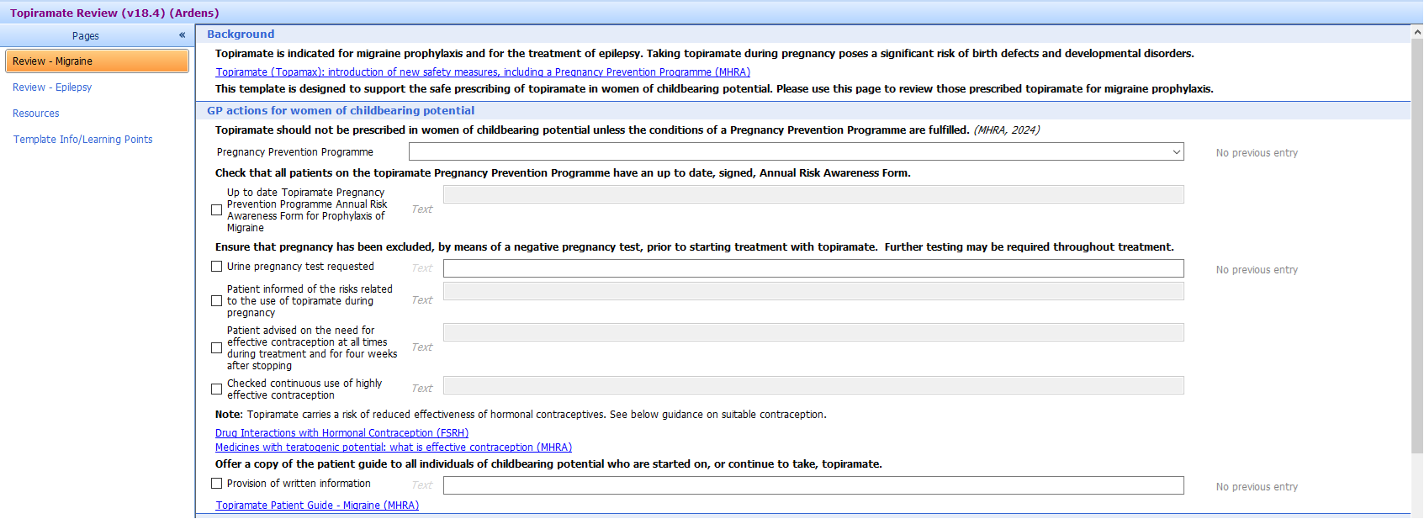

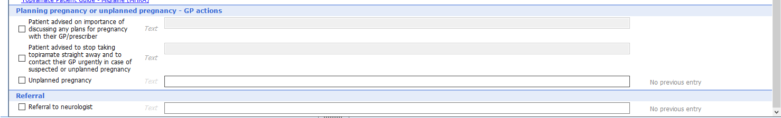

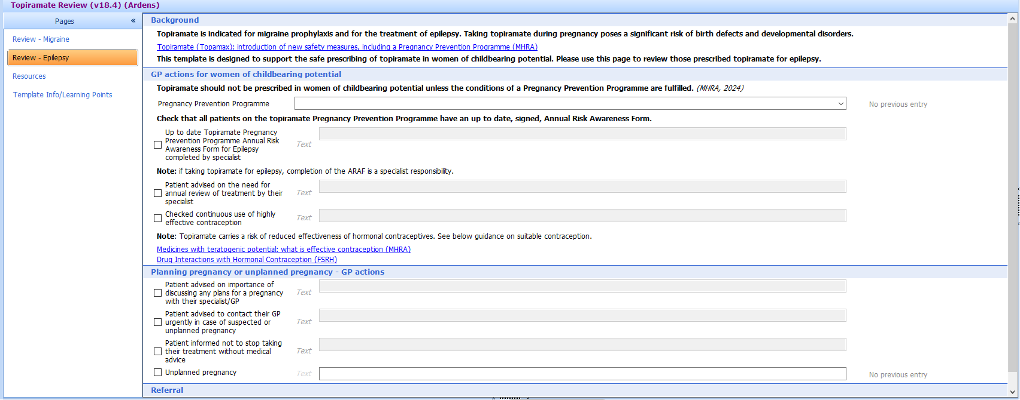

**Identify female patients of childbearing potential prescribed topiramate**

Use EMIS or Ardens searches to identify women and girls prescribed topiramate who may require the PPP and start [highly effective contraception](https://www.fsrh.org/Public/Documents/ceu-clinical-guidance-drug-interactions-with-hormonal.aspx?WebsiteKey=f858b086-d221-4a83-9688-824162920b1b) as appropriate

* **Without clear next follow up or review date**

**>> Send email to department and highlight subject “Topiramate Pregnancy Prevention Programme”**

* **With upcoming neurology appointments in the next 12 months >> No further referral action required from GP but should ensure patient is on highly effective contraception as appropriate.**

**Implement a Standard Operating Procedure for recall and assurance that the PPP is in place for all women of childbearing potential prescribed topiramate**

**Not epilepsy or Migraine prophylaxis? Non-formulary and off label or unlicensed indication?**

**• Complete ARAF Step 1 ONCE only**

**•Document the compelling reason indicates no potential for pregnancy**

**• Code “PPP not needed” (SCTID: 1129791000000104)**

**)**

**• Complete ARAF Step 1 &2**

**• Code “PPP started” (SCTID: 1129771000000103)**

**• Organise annual review and complete ARAF**

**Under active follow up by neurology (epilepsy) specialist**

**Ascertain topiramate indication(s) and ensure correctly read coded**

**If PPP applicable**

**Refer patient to Epilepsy team at NBT via ERS (or appropriate specialist team) and indicate ‘Topiramate Pregnancy Prevention Programme’ as referral reason, specialist to complete the ARAF**

**Review indication and seek advice from relevant specialist team e.g. Pain Clinic, Mental Health Team**

**If PPP not applicable**

**Review prophylaxis of migraine choice and inform the risk of taking topiramate by using** [**Patient Guide Prophylaxis of migraine**](https://www.medicines.org.uk/emc/rmm/3082/Document)

**HCP to complete the ARAF with patient (or responsible person) and document in clinical record**

**For epilepsy** - *Advise not to stop taking topiramate without the advice of a specialist as this will risk worsening epilepsy.*

**For women and girls of childbearing potential who remain on topiramate and if PPP is applicable:**

Discuss with patient(s) the need to use highly effective contraception* throughout treatment and for at least four weeks after the last dose of topiramate.

See guidance from The Faculty of Sexual and Reproductive Healthcare (FSRH) on potential drug interactions with hormonal contraceptives.

*Topiramate is an enzyme inducer that reduces effectiveness of hormonal contraceptives. See [**FSRH CEU Guidance: Drug Interactions with Hormonal Contraception**](https://www.fsrh.org/Public/Documents/ceu-clinical-guidance-drug-interactions-with-hormonal.aspx?WebsiteKey=f858b086-d221-4a83-9688-824162920b1b)

**For Prophylaxis of migraine**

**Discharged/Not known to neurology (epilepsy) specialist**

**Provide** [**Patient Guide Epilepsy**](https://www.medicines.org.uk/emc/rmm/3081/Document)**. Inform patient that as part of the new PPP measures, HCPs will be in contact to organise a review to discuss their treatment and address their questions**

**If currently pregnant and prescribed topiramate:**

* Topiramate is contraindicated in pregnancy for prophylaxis of migraine and should be stopped straight away.
* **Topiramate for epilepsy should not be stopped abruptly or without specialist input.** Work with local specialist teams as appropriate to the indication.