**Bristol Regional Genetics Service guidelines regarding mammography surveillance for asymptomatic women who have a family history of breast and / or ovarian cancer.**

Based on the Nice Familial Breast Cancer Guidance (clinical guidance cg164, 2013, last updated 2019)

|  |  |  |
| --- | --- | --- |
| Risk Group | % Lifetime risk of breast cancer | Surveillance NICE recommends offering * |
| Near population | 12-16 | National programme only, i.e. 3 yearly from 50. |
| Moderate | 17-29 (3-8 between age 40-50) | Annual mammography 40-49, return to national programme aged 50. |
| High | 30-40 | Annual mammography 40-59, return to national programme aged 60 |

*Any surveillance outside of the NICE recommendations would be at the discretion of the local breast screening clinic.

**Referrals for surveillance to your local Family History Clinic** **should only be made for patients between ages 40-60, see below for criteria**.

Refer to Clinical Genetics for discussion about predictive testing & cancer management**1**

Yes

**Start**. Known cancer syndrome/gene mutation in family?

No

**Age of patient?**

Under 40

Not eligible for referral unless have BRCA1 or 2 mutation or other highly penetrant single gene disorder.

**Refer to local Family History Clinic for assessment.**

Referrals must be made by eRS

Clinics are held in:

* Bristol (Southmead Hospital, NBT)
* Bath

(Royal United Hospital, RUH)

* Taunton (Musgrove Park Hospital, MPH)
* 1°relative diagnosed with breast cancer aged <40.
* 1°relative & 2°relative diagnosed with breast and / or ovarian cancer any age, same side of family.
* 2x 1°relatives diagnosed with breast and / or ovarian cancer any age.
* 1°relative with bilateral breast cancer any age.
* 1°relative diagnosed with male breast cancer any age.

40-49

Breast cancer only.

* One 1° relative and one 2° degree relative diagnosed before average age 50, same side of family.
* Two 1° degree relatives diagnosed before average age 50.
* Three or more 1° or 2° relatives diagnosed at any age ( but at least one 1° relative) , same side of family2.
* 1°relative diagnosed with male breast cancer any age.
* One 1°relative with bilateral breast cancer, where 1st primary diagnosed before age 50.

Breast and ovarian cancer / ovarian cancer only.

* 1°relative & 2°relative diagnosed with breast and / or ovarian cancer any age, same side of family .*

50-59

Over 60

Not eligible for referral unless have BRCA1 or 2 mutation or other highly penetrant single gene disorder.

1°relative = First degree relative i.e. parents, child, brothers, sisters.

2°relative = Second degree relative i.e. grandparent/child, aunts/uncles, nieces/nephews.

1°kinship = First degree relatives of each other.

Do not ignore family history through a male as men can carry high-risk breast cancer genes (although the associated cancer risks for men are much lower).

1 If patient does not want genetic testing, still consider seeking advice regarding surveillance.

* Affected 2° relatives must be first degree relatives of each other or if not, intervening relative must be male

Examples.

40-49.

Eligible.

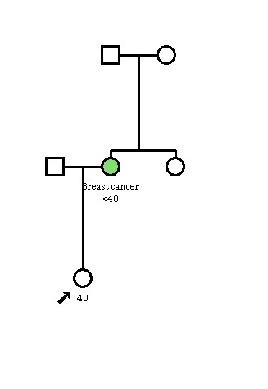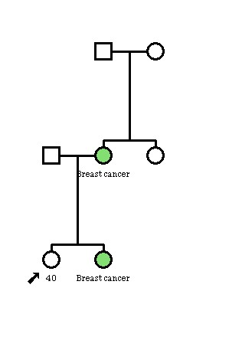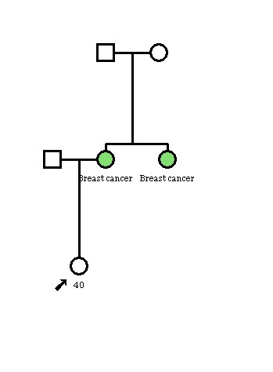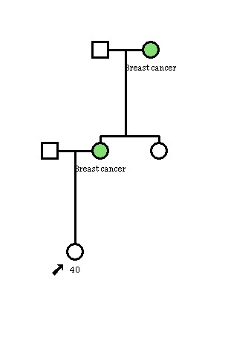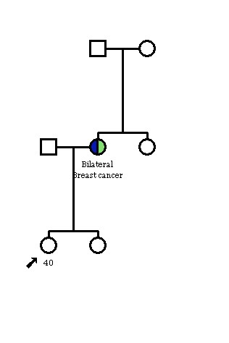



Breast cancer

40

Examples.

50-59.

Eligible.



Breast cancer

50



Breast cancer

50

Breast cancer

Breast cancer



Breast cancer

50

Breast cancer



Breast cancer

50

Breast cancer

Average age of both diagnoses <50yrs

50

Bilateral breast cancer.

First primary diagnosed <50yrs



Not eligible unless have BRCA1 or 2 mutation or other highly penetrant single gene disorder.

Examples.

Breast and Ovarian cancer diagnoses

Eligible



50

Ovarian cancer