Clinical GUIDELINE
guidance for general practice and emergency departments for the management of pyrexia of unknown origin in ADULT patients with congenital heart disease
SETTING | All health care settings in South Wales and South West Congenital Heart Disease Network
GUIDELINE FOR
PATIENT GROUP | Adults with congenital heart disease (repaired or unrepaired)
___________________________________________________________________________________
BACKGROUND:

Infective endocarditis disproportionately affects patients with congenital heart disease. Early identification is crucial for best outcomes, but clinical diagnosis can be challenging. Whilst the index of suspicion is high when patients present to adult congenital heart disease services due to experience unfamiliarity, it may not be so when they present to their GP or emergency departments. This guideline is designed to help providers in primary care and in emergency departments to identify affected patients as early as possible.

GUIDANCE:
For Patients Presenting to General Practice
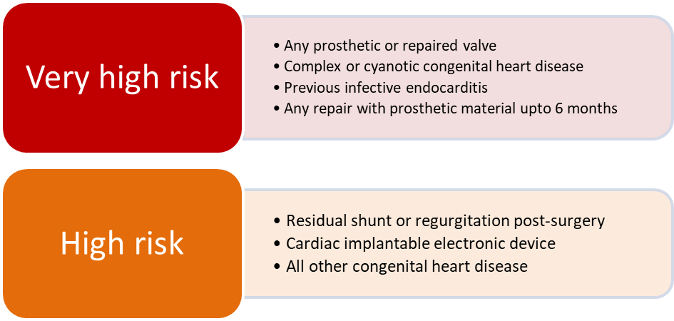
If patient presents with a history of congenital heart disease and temperature >38°C for more than 3 days, first consider risk:

Then, follow the algorithm below:

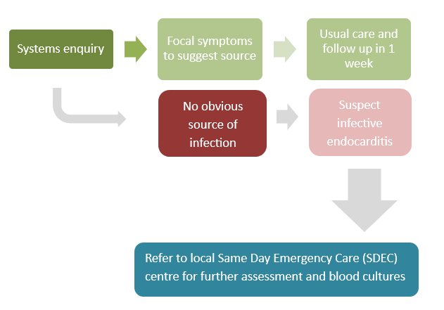

For Patients Presenting to the Emergency Department
If patient presents with history of congenital heart disease and temperature >38°C for more than 3 days, first consider risk, as above:

Then, follow the algorithm below:

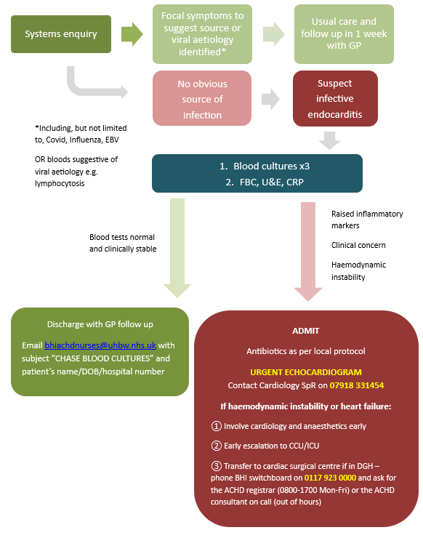
_________________________________________________________________________

RELATED  DOCUMENTS AND PAGES | Carvajal, V., Reyes, F.B., Gonzalez, D. et al. Endocarditis in Adult Congenital Heart Disease Patients: Prevention, Recognition, and Management. Curr Cardiol Rep 26, 1031–1045 (2024).  https://doi.org/10.1007/s11886-024-02103-9.  Delgado, V et al. ESC Scientific Document Group , 2023 ESC Guidelines for the management of endocarditis. European Heart Journal, Volume 44, Issue 39, 14 October 2023, Pages 3948–-042. https://doi.org/10.1093/eurheartj/ehad193
AUTHORISING BODY | UHBW Clinical Governance Group
SAFETY
QUERIES / CONTACT | Dr S Curtis, Consultant Cardiologist, UHBW
AUDIT REQUIREMENTS | Bienniel review of document

Plan Elements | Plan Details
The Dissemination Lead is:
Is this document: A – replacing the same titled, expired SOP, B – replacing an alternative SOP, C – a new SOP: | C
If answer above is B: Alternative documentation this SOP will replace (if applicable):
Document to be disseminated to: | All members of South Wales and South West Congenital Heart Disease Network, Clinical Leads in Emergency Departments and General Practice throughout Network
Method of dissemination: | Email
Is Training required: | No

Document Change Control
Date of Version | Version Number | Lead for Revisions | Type of Revision | Description of Revision
Mmm yy | 0.00 | (Job title only) | Major/ Minor | Include ALL changes completed in this revision, including title of section in the document.

