**GP Practice Coding – SNOMED codes**

GP practices are recommended to code valproate patient documentation with the suggested coding below. MHRA and [NHS Digital](https://termbrowser.nhs.uk/?perspective=full&conceptId1=1366401000000107&edition=uk-edition&release=v20240313&server=https://termbrowser.nhs.uk/sct-browser-api/snomed&langRefset=999001261000000100,999000691000001104) have advised that the SNOMED codes below are available to support primary care in accurately recording that patients have been informed about the paternal risks of valproate in males. This will then help with subsequent EMIS searching and identifying those patients who have a review outstanding.

* For **new male patients** the practice can record the receipt of the RAF using:

2078961000000109 |Risk Acknowledgement Form for Male Patients Starting Valproate completed (situation)|

* For **existing valproate patients**, a non-specific SNOMED code is appropriate along with a freetext annotation of ‘valproate’ and ‘Risk of Neurodevelopmental Disorder’:

396080005 |Medication side effects education (procedure)|

* **Contraception care education done**: SNOMED code is 150811000119101

**GP Practice GP IT System Searches**

**EMIS** searches:

* can be downloaded and imported into your EMIS Web clinical system to help to identify potentially at-risk patients. **N.B. As with all EMIS searches, please remember that they are only as good as the GP practice coding.**
* The below EMIS search to identifies patients who are coded as having a ‘male’ gender and are aged 10 years or above and are prescribed valproate. Due to the coding relating to gender, this search may identify some male patients who were born female and so a sub-search has also been included.



* **Ardens**:
* **Ardens searches** - have also produced GP practice searches which practices may find helpful which identifies male patients who haven’t had contraceptive advice in the last year so that practices can use this if they wish to proactively call patients or at their next regular treatment review.

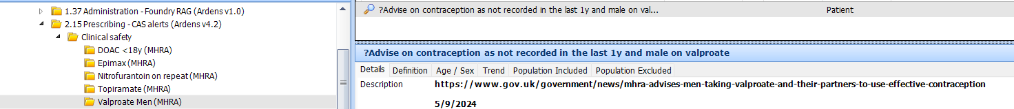

* **Ardens template** – GP Actions for men

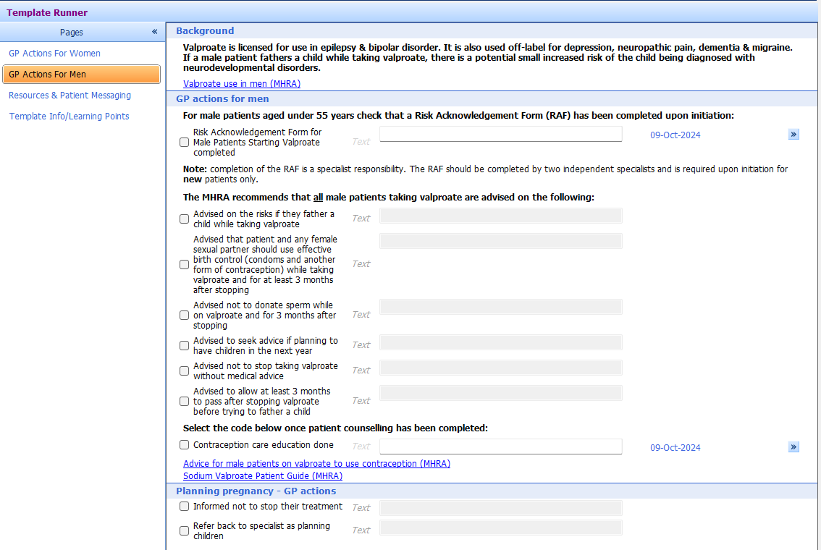

* **Ardens protocol** – notifies prescribers if the practice don’t have both the RAF code and contraceptive care advice.

