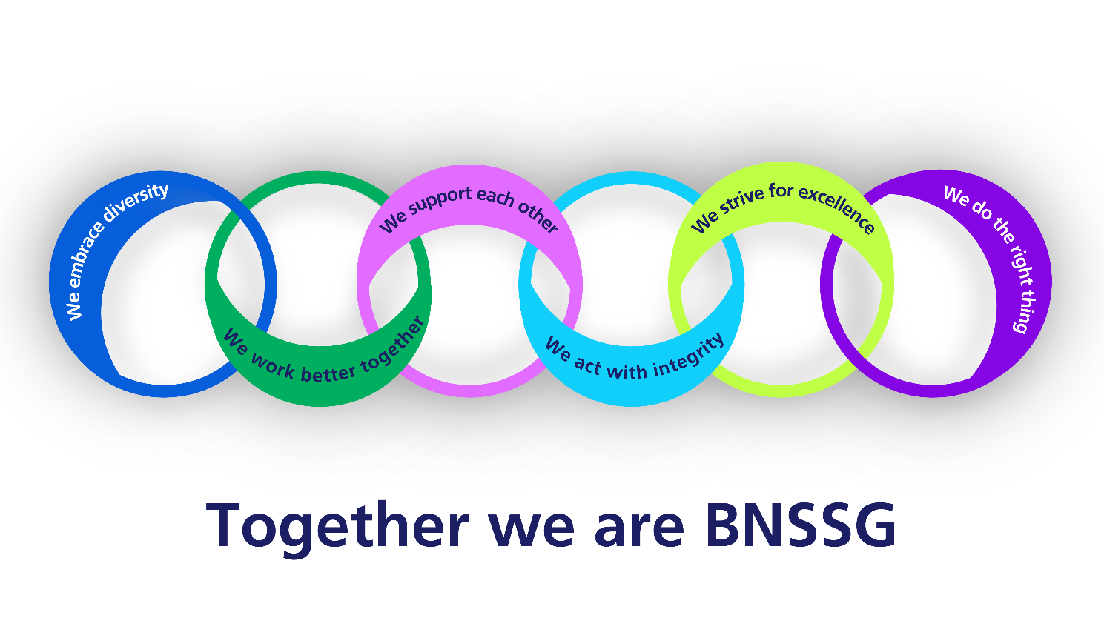
Learning disability and autism newsletter March 2025

Resources for autistic teenagers “know yourself”  by the National autistic society  Resources for autistic teenagers | Hoarding  This has come up as a theme in recent LeDeR reviews of autistic people and/or people with learning disability  Mind has a factsheet for patients and families: hoarding-2018.pdf  Easy read leaflet on Remedy |  | Primary Care Learning Brief: Increase primary care access for citizens with a learning disability from ethnic minority background  This learning brief summarises the findings of a project by the BNSSG ICB and Autism Independence to  1.Raise awareness of the GP learning disability register  2. Support people to be added to the GP LD register  3. Provide support to access learning disability annual health checks (AHC)  Please check out the recommendation for primary care on our remedy page.  Posters to promote annual health checks in different languages can be found here: Resources for Learning Disability Annual Health Checks and Health Action Plans (Remedy BNSSG ICB)
Next webinar:  Breaking Barriers: Emerging Issues in Learning Disabilities and Health  The ICB and Sirona Adult Learning Disability Health Service are running the next free webinar on Wednesday the 23rd April 2024 12.30 to 2pm.  Topics include GP autism assessment and post diagnostic support, hoarding, pneumococcal vaccine and an introduction to the new health passport.  To register please follow this link:  https://www.eventbrite.co.uk/e/breaking-barriers-emerging-issues-in-learning-disabilities-and-health-tickets-1251607775549 |  | Pneumococcal vaccine:  In 2021 over 50% of people with a learning disability died before they were 65 years old compared to about 1 in 10 of the general population  Respiratory disease is one of the biggest causes of death for people with a learning disability  Up to 15% of all respiratory death were caused by aspiration pneumonia (LeDeR 2021)  Respiratory death are often avoidable deaths.  Since Jan 2025 people with learning disability and increase risk of aspiration can have a pneumococcal vaccine (the green book will be updated in due cause).  Risk of aspiration can include  Swallowing problems, Dementia, Down’s, Cerebral palsy  Tracheostomy, NG feeding, Periods of unconsciousness, Seizures, Poor mobility or posture, Frailty, Reflux  Here is a link to an easy read patient leaflet: Easy Read pneumococcal guide - Health Publications |  | STOMP/STAMP  eLfH and NHSE MindEd  have an excellent online education resource for health care professionals:  New sessions available on stopping over-medication of people with a learning disability and autistic people - elearning for healthcare
Any feedback:

Juliane.matthies@nhs.net

