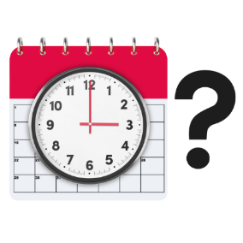 | You have an appointment
 | You will see [professional name]  This is a picture of [professional name]  [professional’s name] is a [profession or doctor].
X  TYPE | Your appointment is on [date in full].
X X : X X | It is at [time].
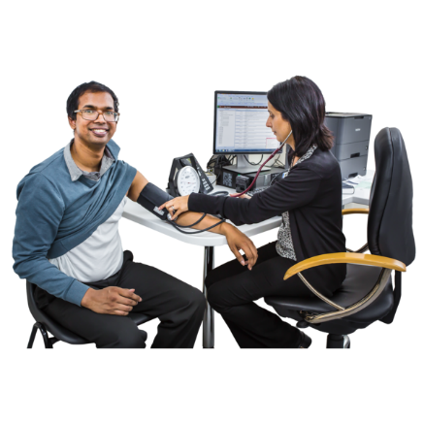 | The appointment is for a health check
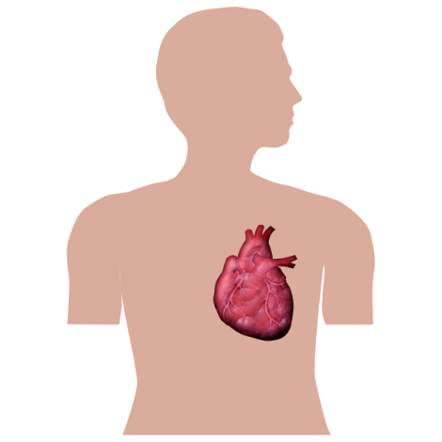 | The appointment is for a heart check
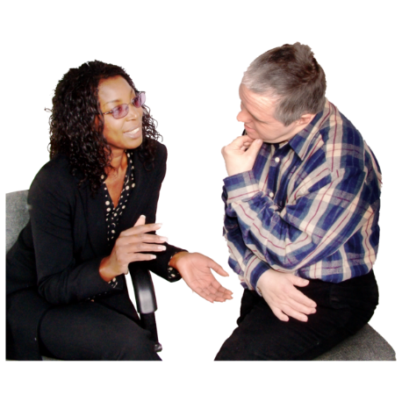 | The appointment is to talk about  how you are going
 | The appointment is to see the doctor
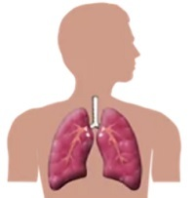 | The appointment is to check your lungs
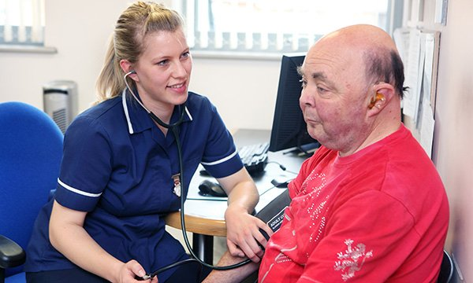 | The appointment is to see the nurse
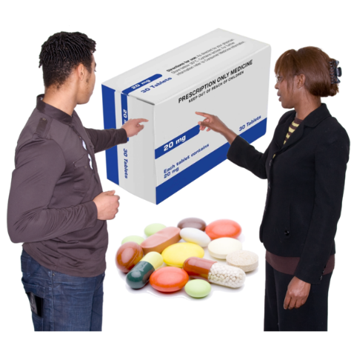 | The appointment is to check your medicine
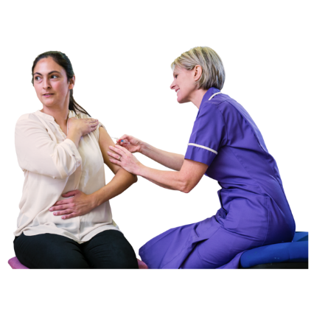 | The appointment is for a vaccine/injection
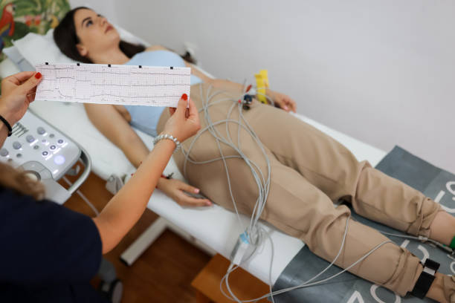 | The appointment is for an ECG
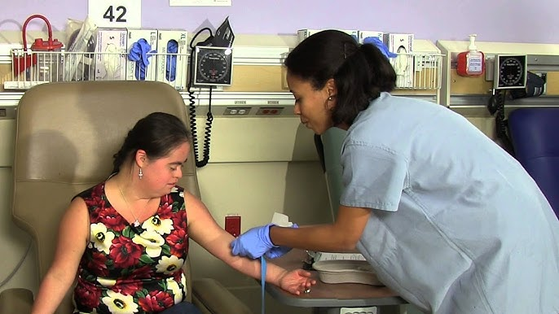 | The appointment is to have a blood test
 | The appointment is at [address]  -if a large building like a hospital, or town centre, include level, clinic name-  This is what the building looks like.
 | Do you have a question?  You can call [name or clinic or just me/us] on [number]
 | If you need to change the time call  [name or clinic or just me/us]  on [number]
 | From [name of person sending letter]
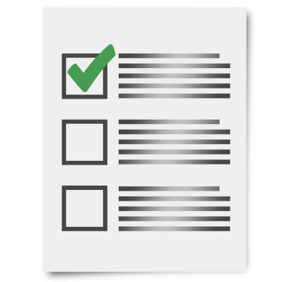 | Take these things to the appointment:

