**Creating a Cross Organisational Task**

In workflow manager select add task:

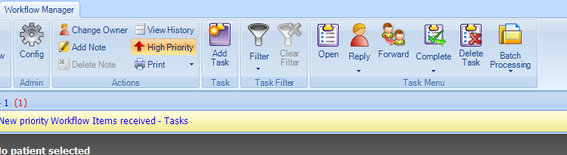

Task Type: Select Admin Note

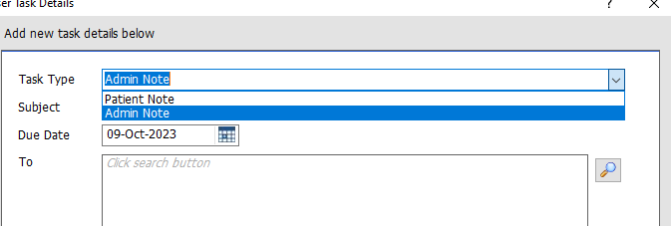

Subject: Medical Examiner Referral

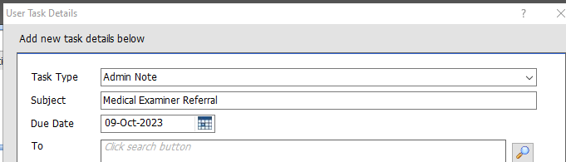

To: use magnifying glass to search Shared Organisations – Teams – North Bristol NHS Trust and select “BNSSG Medical Examiner Service Referrals” – double click.

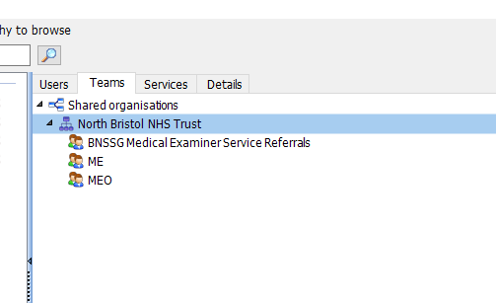

Press OK.

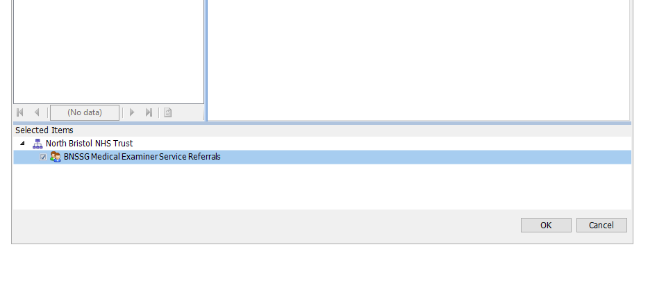

Notes: Include Name of Patient, NHS Number and Date of Birth.

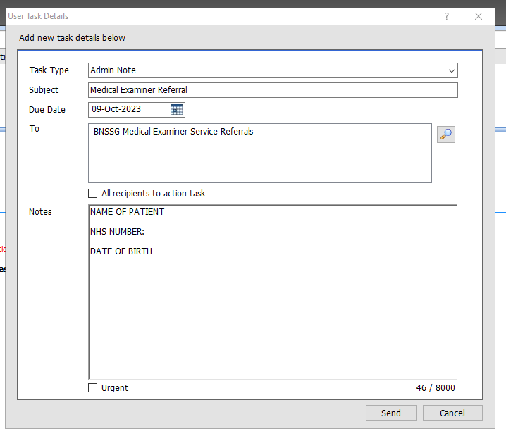

Then press send.