Dear GP, 

My name is……………..

I like to be called…………….

I am …….…years old and I have a Learning Disability. Please make sure I am on your Learning Disability Register.

Below is some useful information about me.

I would like to have my Annual Health Check.

Please contact ……………………………………………….(me / my parents / carer) to arrange an appointment.

This is the best way to contact me…………………..( sms/mobile/ phone call/letter/email)

I can / cannot come to the surgery for this.

Below are some reasonable adjustments I will need when we meet.

Thank you

I have problems seeing or hearing.

I need alternative forms of communication like Makaton, BSL

Any other reasonable adjustments or comments

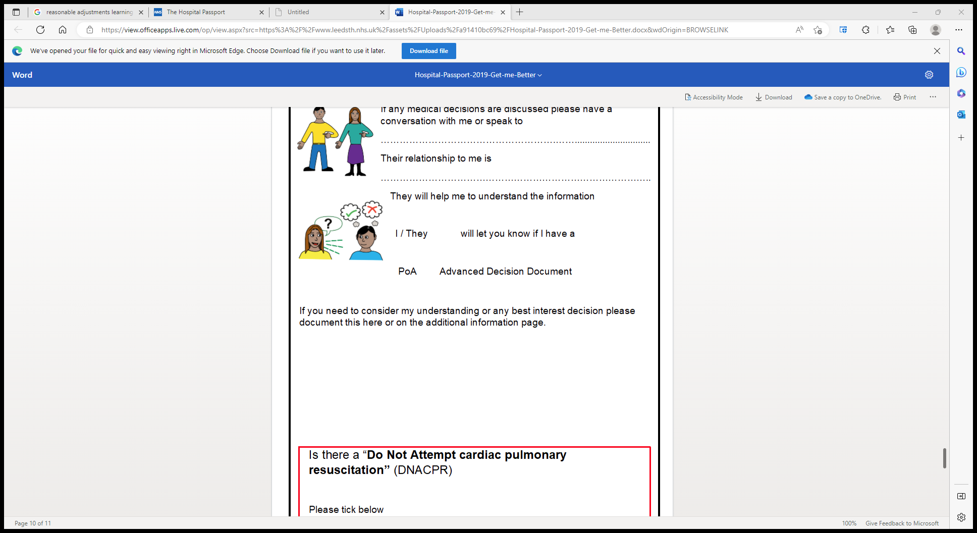

We acknowledge and extend our thanks to Leeds and York Partnership NHS Foundation Trust and the Live well South West Team for permitting use and modification of their templates

Plymouth Community Learning Disabilities Team/FMS/09-2020