About This Service:
- This is an outpatient based rapid response service for joint decision making between primary and secondary care physicians.
- It is aimed at situations where the health of a patient is deteriorating rapidly and hospital admission may be the outcome unless there is access to diagnostics and senior clinical opinion.

We can offer:
- A rapid clinic review within 1 week according to need (Red on RAG rated referrals).
- A Consultant led Comprehensive Geriatric assessment (CGA)
- Access to X-ray, CT head and limited access to further CT and Ultrasound investigations.
- Access to same day blood tests
- A summary letter will be sent to your surgery by 3.00pm the following day

*In any situation where you feel that admission is likely, but there is some uncertainty then we encourage you to*

Please CALL the “Geriatrician of the Day” on 07738859048 or via NBT switchboard
This is answered Mon-Fri 0800-1600 pm
For ANY NON CLINICAL questions, transport, changing booking or anything else:
Please call the Rapid Access Older Persons clinic secretary on 0117 414 6005
Please provide a Mobile phone number or an Urgent Contact number

When does this service run?

- New Patients are seen Wednesday and Thursday mornings. N.B. the appointment may take up to four hours-Please allow a four hour transport window

Referral to this service is by completion of the proforma below
Please e mail to:nbn-tr.olderpersonsrapidaccess@nhs.net

Criteria for Referral

Frail patients most likely to benefit:

- Pathology in multiple organ systems leading to the patient deterioration.
- Medically unexplained falls/ New medically unexplained deterioration in mobility
- Acute unexplained increase in care needs
- Unexplained/unintentional weight loss in frail patient

Which patients are eligible?

- Patients must be over 60 years old with a clinical frailty score of 4 or over (Rockwood-see below)
- Not obviously requiring immediate emergency admission
- Social circumstances clear, no intractable social crises

Clinical Frailty Scale score:
(Rockwood Frailty score)

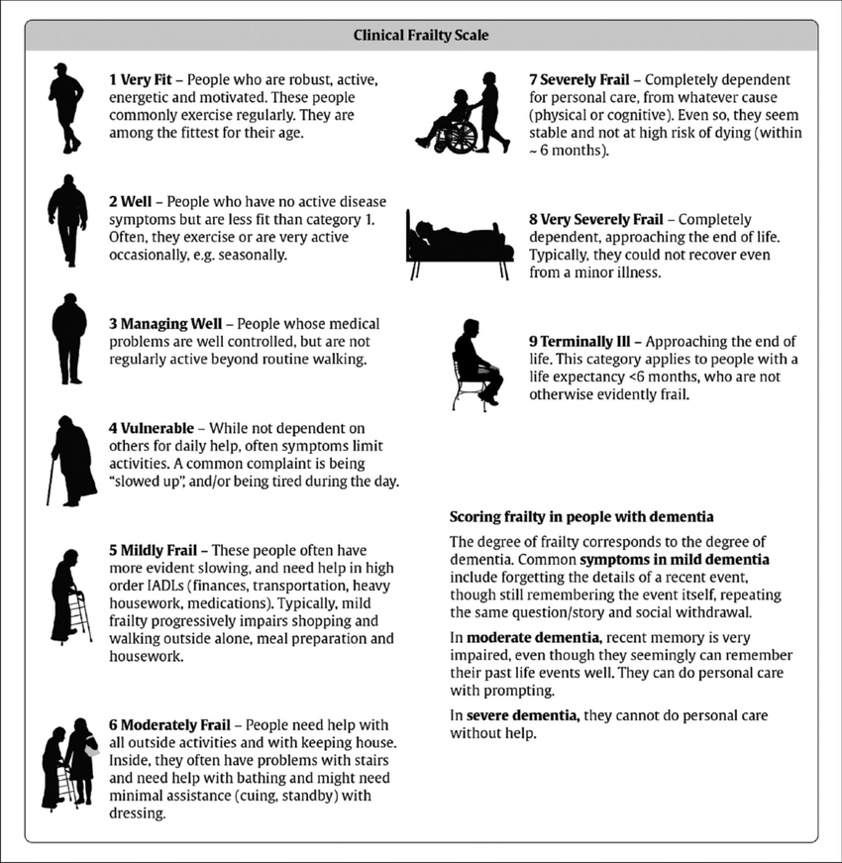

Older Person Rapid Access Referral Form
Please E mail this form to: nbn-tr.olderpersonsrapidaccess@nhs.net

Patient Details: Referral Date: Short date letter merged
Patient’s Name: | Full Name
Date of birth: | Date of Birth |  | NHS number: |  | NHS Number
Address: | Home Full Address (stacked)
Home Tel: | Patient Home Telephone | Mobile Tel: |  |  | Patient Mobile Telephone
Ethnicity: | Ethnic Origin |  |  | Interpreter needed  Language?
Nursing or Care Home resident:
DNAR form and status

GP Details:
Usual GP: | Usual GP Full Name | Referring GP & Mobile Number
Practice: | Organisation Name | Practice Address: | Organisation Full Address (stacked)
Practice Tel: |  | Organisation Telephone Number

Next of Kin
Name: | Relationship: | Telephone

REASON FOR REFERRAL – Please give as much detail as possible:
(Please describe issues you want the clinic to address, rather than just pasting information in from clinical record)
Main Clinical Problem
Please describe the clinical history and any specific questions you may have:

