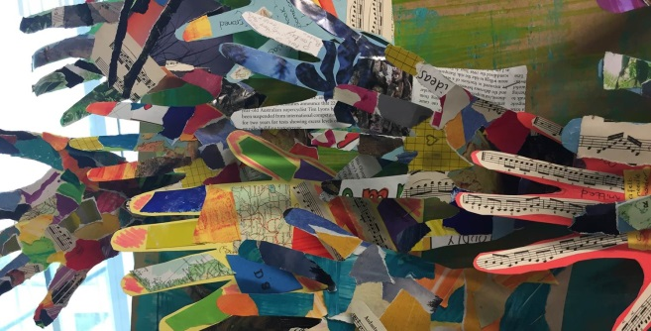
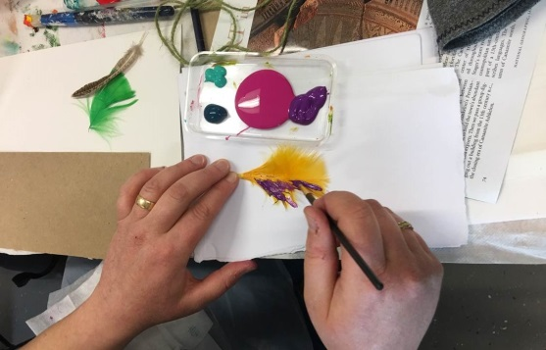
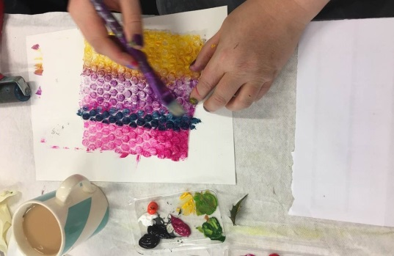
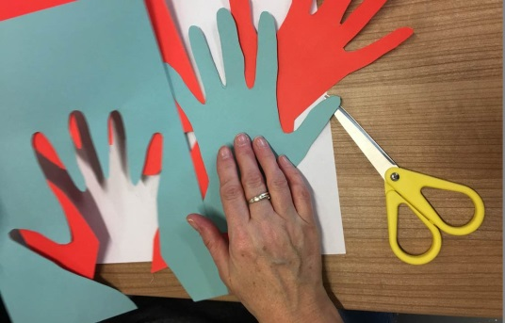
Fresh Arts
Arts on Referral
A free 6-week Arts Workshop Programme to Support People Living with Chronic Pain
Do you live with chronic pain? Taking part in a creative activity has helped others better manage pain. This arts group aims to help you meet and find support from others in a similar situation. The group explores a range of creative activities led by artist Ali Brown. This group is open to everyone. Whether or not you think you are creative, Ali will support you to explore a range of fun and enjoyable activities.

To find out more and book a place you can:
Ask your clinician, ask at the Chronic Pain Clinic Reception, email fresh.arts@nbt.nhs.uk or call Jennifer Mills, Arts on Referral Manager on 07920 413022

What people have said about Arts on Referral...
“This course has helped me step away from my own judgements and others’ judgements”

“Every time I leave here, I’m done but it’s worth it because it’s enjoyable, achievement, connection, happy. Going home, I smile at people.”

“Really good for my wellbeing”

