Intrahepatic Cholestasis of Pregnancy
(obstetric cholestasis)
Diagnosis & management
Scope: Clinical Practice
Version 5 | Valid from 11/11/2022 | Review due 11/11/2025 | Authors: Dr Stephen O’Brien

Contents
Best Practice Points 2
Community Care Pathway – Intrahepatic Cholestasis of Pregnancy 3
Diagnosis & Management 4
Introduction and Background 4
Clinical Features 4
Diagnosis 4
Implications for women and babies 4
Stillbirth 5
Role of Ultrasound in management of ICP 5
Management of ICP 6
Mild ICP (TBA 19 - 39) 6
Moderate ICP (TBA 40 – 99) 7
Severe ICP (TBA >99) 8
Medication 9
Audit 9
References 9

Best Practice Points

- Diagnosis of Intrahepatic Cholestasis of Pregnancy (ICP) is confirmed by an elevation in total bile acids (TBA) ≥19 mmol/L in the presence of a history of pruritis commencing in mid trimester
- ICP should be classified based on the highest recorded TBA (even if they improve) with mild (≥19 to 39mmol/L), moderate (≥40 to 99mmol/L) and severe (≥100mmol/L)
- Women should be managed differently based on the severity of ICP
- Unless TBA >100, additional investigations (immunology, virology, liver ultrasound etc) are not required
- ICP with a TBA >100 is associated with small increased rates of meconium staining of liquor, NICU admission, premature delivery and stillbirth. Intrauterine growth restriction and oligohydramnios are not associated with ICP
- Timing of delivery should be based on the severity of ICP
- The risk of stillbirth in mild and moderate ICP is comparable to the general obstetric population without the condition
- Women with severe ICP are at greatest risk of stillbirth and should be offered earlier induction of labour (IOL)
- Electronic fetal monitoring during labour is recommended for women with severe ICP
- LFTs should be checked six weeks postpartum to confirm resolution

Community Care Pathway – Intrahepatic Cholestasis of Pregnancy

Review by community midwife / GP for thorough history, Liver Function Tests and Total Bile Acids
If associated with upper abdominal pain, please refer to QAU guideline for Abdominal Pain

Normal results
Reassure woman
If remains symptomatic, repeat tests every 2 weeks

Abnormal results
Mild or moderate ICP – TBA >19 ≤99 – refer to ANC for review within 2 weeks. No further investigations are required
If severe ICP (TBA ≥100) - refer to QAU for:
- BP, urinalysis, SFH and CTG
- Blood and USS investigations (order set on ICE, details in main guideline)
- Offer management based on TBA – see full guidance for pharmacology & ANC appointment schedule

Diagnosis & Management

Introduction and Background

Intrahepatic cholestasis of pregnancy (ICP), also known as obstetric cholestasis (OC) is a multifactorial condition of pregnancy characterised by pruritus in the absence of a skin rash with elevated total bile acids (TBAs), neither of which has an alternative cause and both of which resolve after birth¹. Severity of ICP can be determined by the magnitude of elevation in bile acids. Whilst liver transaminases may be raised in ICP they should not be used to diagnose the condition or inform decisions around IOL.
ICP has an incidence of 0.7% in the white UK population. It affects 1.2% to 1.5% of the UK Asian population².
ICP can recur if women have had ICP in a previous pregnancy.

Clinical Features
Classically the presentation is in the second or third trimester with intense pruritis on the soles and palmar surfaces which can cause significant morbidity through sleep deprivation. Excoriations may be associated but no rash should be apparent. Pale stools and dark urine may rarely be a feature

Diagnosis
This is confirmed by elevated TBAs in the presence of a history of pruritis commencing in mid trimester. Whilst transaminases may be raised, a diagnosis of ICP cannot be made without elevation in TBAs.

Implications for women and babies
The importance of ICP relates to the potential increased risk of adverse fetal outcomes including prematurity (iatrogenic & spontaneous), meconium passage in labour, admission to NICU and stillbirth. It is also associated with significant maternal morbidity secondary to symptoms of intense pruritis which can lead to significant sleep deprivation
The most comprehensive meta-analysis to date demonstrated increased fetal risks associated with intrahepatic cholestasis of pregnancy
• Spontaneous preterm delivery OR 3.47 (CI = 3.06-3.95)
• Iatrogenic preterm birth OR 3.65 (CI = 1.94-6.85)
• Meconium-stained amniotic fluid OR 2.60 (CI = 1.62-4.16)
• Neonatal unit admission OR 2.12 (CI = 1.48-3.03)

Stillbirth

Stillbirth appears to be linked in a dose dependent fashion to the magnitude of elevation in serum bile acids. In a comprehensive 2019 meta-analysis it was found that the risk of stillbirth was lowest in women with TBAs less than 40mmol/L and greatest in those with TBAs ≥100mmol/L.

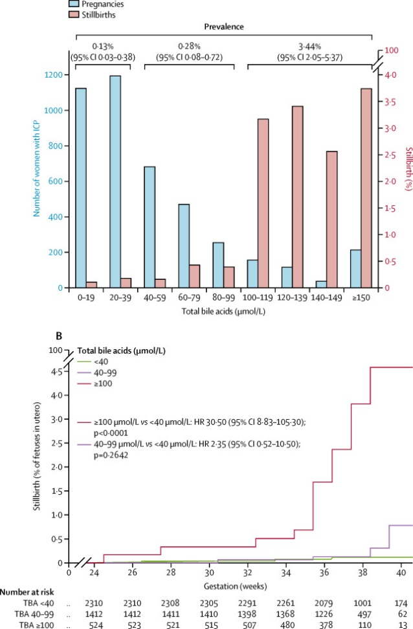

In this study the risk of stillbirth in women with serum bile acids <100 prior to 39 weeks was no greater than women without obstetric cholestasis. It is important to note that the 25% preterm delivery rate in this group may have prevented against later stillbirth.

Role of Ultrasound in management of ICP
There is no evidence that parameters of fetal wellbeing measured by ultrasound (fetal growth, vascular flow and liquor volume) have prognostic value in ICP1. Therefore, ICP is not an indication for ultrasound surveillance.

Management of ICP
Women with mild, moderate and severe ICP should be managed differently. These treatment pathways are laid out on the following pages below. It is important to note that the severity of ICP is determined by the highest recorded bile acids even if they decrease during surveillance. If the patient has co-existent diabetes, please discuss care plan with the maternal medicine team.
For ease of reference please place care plan corresponding to severity of ICP in antenatal page of patient notes. If this severity worsens then please exchange this for the appropriate plan (remembering that ICP severity cannot be downgraded).

Mild ICP (TBA ≥19 - 39)

Delivery | Women with mild ICP should be offered elective delivery by 40 weeks gestation
Initial management | Women with a diagnosis of ICP and a TBA ≤39 should be referred by the CMW to ANC for review within 2 weeks. No further investigations are required.  If already ≥39 weeks gestation/if appointment not available until after 40 weeks, arrange same day review by doctor (SpR or consultant) on AAU
Antenatal management | <34 weeks gestation - Fortnightly TBAs with community midwife  ≥34 weeks gestation - Weekly TBAs with community midwife  ≥39 weeks gestation - Offer IOL or elective caesarean section (if indicated) by 40 weeks gestation  - If TBAs rise to ≥40 or ≥100 re-categorise as moderate or severe ICP accordingly and arrange review in ANC. If referral to ANC would exceed the delivery threshold of moderate or severe ICP, arrange same day review by doctor (ST3+) on AAU
Management of labour | - There is insufficient evidence for or against CTGs in women with peak bile acids below 100 mmol/L. A shared decision can be made based on co-morbidities and preferences.  - Women who chose not to have a CTG during labour and have no other indications for CEFM can labour in a midwifery-led setting
Postnatal management | - Check LFTs 6 weeks post-partum to ensure LFTs have returned to normal  - Women should be informed of the risk of recurrence in subsequent pregnancies  - ICP itself does not influence choice of future contraceptive agents or HRT

Moderate ICP (TBA ≥40 – 99)

Delivery | Patients with moderate ICP should be offered elective delivery at 38 - 39 weeks gestation
Initial management | Women with a diagnosis of ICP and a TBA 40-99 should be referred by the CMW to ANC for review within 2 weeks. No further investigations are required.  If already ≥38 weeks gestation/if appointment not available until after 39 weeks, arrange same day review by doctor (ST3+) on AAU
Antenatal management | <34 weeks - Fortnightly TBA with CMW  ≥34 weeks - Weekly TBA with CMW  ≥38 weeks - Offer IOL or caesarean section (if indicated) by 39 weeks gestation  - If TBAs rise to ≥100 re-categorise as severe ICP and arrange review in ANC. If referral to ANC would exceed this threshold/if past this delivery threshold already, arrange same day review by doctor (ST3+) on AAU
Management of labour | There is insufficient evidence for or against CTGs in women with peak bile acids below 100 mmol/L.  A shared decision can be made based on co-morbidities and preferences. Women who chose not to have a CTG during labour and have no other indications for CEFM can labour in a midwifery-led setting
Postnatal management | - Check LFTs 6 weeks post-partum to ensure LFTs have returned to normal  Women should be informed of the risk of recurrence in subsequent pregnancies  ICP itself does not influence choice of future contraceptive agents or HRT

Severe ICP (TBA ≥100)

Delivery | Women with severe ICP should be offered elective delivery by 36 weeks gestation. In women with exceptionally high TBAs delivery may be required <36 weeks.
Initial management | Women with a diagnosis of ICP and a TBA ≥100 presenting on Antenatal Assessment Unit (AAU) or Wednesday morning Maternal Medicine Antenatal Clinic (ANC) for the first time should have the following test completed:  - Clotting screen  - Liver serology (Hepatitis A, B & C, EBV, CMV and autoantibody screen)  - Request USS liver  - CTG  - Review by ST3+.  The doctor should arrange for the following:  - Referral to Wednesday morning Maternal Medicine antenatal clinic.  - If already ≥36 weeks gestation/ if appointment not available till after 36 weeks, arrange same day review by doctor (ST3+) on AAU
Antenatal management | Consider Vitamin K if evidence of malabsorption (steatorrhea)  <34 weeks - Fortnightly TBAs on AAU  ≥34 weeks - Twice weekly TBAs on AAU  ≥36 weeks - Offer IOL or caesarean section (if indicated)  It is important to note that even if TBAs fall to below 100 the patient should continue to be treated as severe ICP.
Management of labour | - Women with severe ICP should have continuous fetal monitoring in labour (CTG)
Postnatal management | - Check LFTs 6 weeks post-partum to ensure LFTs have returned to normal  - Women should be informed of the risk of recurrence in subsequent pregnancies  - ICP itself does not influence choice of future contraceptive agents or HRT

Medication

Chlorphenamine
The sedative effects of Chlorphenamine may help facilitate sleep but has no direct effect on improving symptoms of itching. A single 4mg oral dose at night may be prescribed for women with ICP.
Aqueous cream with Menthol
Aqueous cream with menthol may reduce symptoms of itching in some women but this is not backed up with evidence from clinical trials
Ursodeoxycholic acid (URSO)
URSO should not be routinely prescribed for women with a diagnosis of ICP

Women with ICP in a previous pregnancy
Women who have had ICP in a previous pregnancy should have a baseline set of LFTs including a TBA at booking or shortly after.

Audit
Audit to be completed if concerns with non-compliance or as part of action plan following safety incident

References

1. Girling, J, Knight, CL, Chappell, L; on behalf of the Royal College of Obstetricians and Gynaecologists. Intrahepatic cholestasis of pregnancy. BJOG. 2022; 129(13): e95– e114. https://doi.org/10.1111/1471-0528.17206
2. Kenyon AP, Tribe RM, Nelson-Piercy C, Girling JC, Williamson C, Seed PT, et al. Pruritus in pregnancy: a study of anatomical distribution and prevalence in relation to the development of obstetric cholestasis. Obstet Med. 2010 Mar;3(1):25–9.
3. Geenes V, Chappell LC, Seed PT, Steer PJ, Knight M, Williamson C. Association of severe intrahepatic cholestasis of pregnancy with adverse pregnancy outcomes: a prospective population-based case-control study. Hepatology. 2014 Apr;59(4):1482–91.
4. Gurung V, Middleton P, Milan SJ, Hague W, Thornton JG. Interventions for treating cholestasis in pregnancy. Cochrane Database Syst Rev. 2013;6:CD000493.

5. Chappell LC, Gurung V, Seed PT, Chambers J, Williamson C, Thornton JG, et al. Ursodeoxycholic acid versus placebo, and early term delivery versus expectant management, in women with intrahepatic cholestasis of pregnancy: semifactorial randomised clinical trial. BMJ. 2012;344:e3799.
6. Oviada C et al. Association of adverse perinatal outcomes of intrahepatic cholestasis of pregnancy with biochemical markers: results of aggregate and individual patient data meta-analyses. The Lancet. 2019 Mar;393 p899-909
7. Chappell L et al. Ursodeoxycholic acid versus placebo in women with intrahepatic cholestasis of pregnancy (PITCHES): a randomised control trial. The Lancet. 2019 Aug;394 p849-860

Responsibility | Name | Division / Specialty | Job Title
Authorised by | Stephen O’Brien | Maternity | Consultant - Fetal Medicine
Reviewer | Rachel Ion | Maternity | Consultant – Maternal Medicine
Reviewer | Carli Bleaken | Maternity | AN IP SWS
Reviewer | Fiona Scriven | Maternity | Quality Lead
Ratified by extraordinary meeting 11/11/2022 due to immediate changes to practice. Formal ratification due December 22

