A Regional Guideline for the Evaluation of Cardiovascular Risk before the prescription of Romosozumab: covering Bath, Bristol, Oxford, Swindon, Weston-Super-Mare and Yeovil
BG Faber¹, S Dahou², A Tindale³, M McGarvey⁴, F Macrae¹, C Shere¹, C Cockill⁵, S Webber², T Reynolds², SJ Ritchie², D Collins⁶, G Iyer⁷ , M Roy², S Aziz⁸, E Rose-Parfitt¹, CL Gregson⁹, S Hardcastle⁹, T Ahmed⁹, K Javaid¹⁰, EM Clark¹, JH Tobias¹
1. Rheumatology, North Bristol NHS Trust, Bristol
2. Rheumatology, University Hospitals Bristol and Weston, Bristol
3. Cardiology, Royal Brompton and Harefield Hospitals, London
4. Cardiology, King’s College Hospital, London
5. Rheumatology, Yeovil NHS Trust, Yeovil
6. Rheumatology, Great Western NHS Trust, Swindon
7. Primary Care, Bristol, North Somerset and South Gloucestershire Integrated Care Board
8. Cardiology, North Bristol NHS Trust, Bristol
9. Older Person’s Unit/Rheumatology, Royal United Hospital NHS Trust, Bath
10. Rheumatology, John Radcliffe Hospital, Oxford

This guidance or earlier versions were formally approved by the following:
- Medicine Guidance Group, North Bristol NHS Trust on 22nd May 2023
- Area Prescribing and Medicines Optimisation Committee (APMOC), Bristol, North Somerset and South Gloucestershire Integrated Care Board on 13th June 2023
Romosozumab can be prescribed to post-menopausal women with osteoporosis (NICE 2022):
- who are at imminent fracture risk (“severe osteoporosis with a major osteoporotic fracture in the past 24 months”).
- regardless of previous treatment (i.e. Romosozumab can be used first line).

The National Osteoporosis Guideline Group and the Royal Osteoporosis Society suggest that referral for, and consideration of treatment with Romosozumab, is prioritised in postmenopausal women who have had a major osteoporotic fracture within 24 months, with any one of the following:
- a BMD T-Score ≤-3.5 (at the hip or spine), or
- a BMD T-score ≤-2.5 (at the hip or spine) and either
  - vertebral fractures (either a vertebral fracture within 24 months or a history of ≥2 osteoporotic vertebral fractures), or
  - very high fracture risk (e.g., as quantified by FRAX).

There are concerns about the risk of cardiovascular and cerebrovascular events on Romosozumab:
- The ARCH trial comparing Romosozumab vs Alendronate found an increased risk of cardiac ischaemic events (CIE) (OR 2.65 95% CI 1.03-6.77) and cerebrovascular events (CVE) (OR 2.27 95% CI 0.93-5.22) in the Romosozumab arm (1)
- The FRAME trial comparing Romosozumab followed by Denosumab vs Placebo followed by Denosumab found no increased risk of either CIE (OR 1.00 95% CI 0.50-2.00) or CVE (OR 0.91 95% CI 0.38-2.14) (2)
- The BRIDGE study was a much smaller trial comparing Romosozumab vs Placebo in men and found similar results to the ARCH trial but with broad confidence intervals (CIE OR 3.55 95% CI 0.18-69.95 & CVE OR 1.50 95% CI 0.15-14.65) (3)
- A meta-analysis including ARCH, FRAME and BRIDGE showed weak statistical evidence of an increased risk of CIE (OR 1.54 95% CI 0.90-2.64) and CVE (OR 1.44 95% CI 0.80-2.58) (4)
- Further information in Appendix 1
The European Society of Cardiology have produced the HeartScore which is a well validated measure to predict cardiovascular risk in older populations, which places individuals into 3 risk categories (Green – low risk, Amber – medium risk and Red – high risk) (5).
This guidance that follows is designed for secondary care physicians running specialist osteoporosis services.
Assessing cardiovascular risk before the prescription of Romosozumab:
Previous MI or Stroke?
(including poorly controlled Angina or proven TIAs)
Do NOT prescribe Romosozumab
(Record that it is contraindicated)
Information required:
- Blood tests
- Non-fasting Lipid Profile *
- U&Es inc eGFR/Creatinine clearance
- Calcium (to check for hypocalcaemia)
- Systolic BP
- Smoking status
- Diabetes mellitus status
N.B. Assessment for secondary causes of osteoporosis is required as part of routine clinical practice, and is not covered in this guidance

Yes

No

Do a European Society of Cardiology HeartScore^
For ethnic minority patients a correction factor is needed (Appendix 2&3)
For diabetic patients consider them Red risk unless certain criteria met (Appendix 4)

sfad

HeartScore gives a risk category accounting for the age of the patient:
  - Green – proceed to Romosozumab prescription
  - Amber – proceed to Romosozumab prescription but secondary care team to recommend lifestyle advice (Appendix 5) and suggest the patient contact their GP Surgery regarding pharmacological strategies for blood pressure and cholesterol control (Appendix 5)
  - Red – could proceed to Romosozumab prescription but CVD risk may be high enough to preclude treatment#. Secondary care team to recommend lifestyle advice (Appendix 5) and suggest the patient contact their GP Surgery regarding pharmacological strategies for blood pressure and cholesterol control (Appendix 5)
Red risk indicates a >2-fold increase from the recommended 10-year cardiovascular risk for that age group

Dose:
Romosozumab 210mg subcutaneous injection once monthly for 12 months. Following treatment with Romosozumab (12 months), treatment with Alendronate, Zoledronate or Denosumab should be initiated without delay.

*No need to repeat if done in the last 12 months. No need for fasted cholesterol as according to the American College of Cardiology fasted vs unfasted LDL and HDL offer similar prognostic value. ^HeartScore by the European Society of Cardiology is a validated scoring system for CVE prediction for both a young and older population (5). #Secondary care team to decide if Romosozumab prescription is appropriate in the context of CVD risk.
Appendix 1 Risk of cardiovascular, cerebrovascular and MACE events(4)
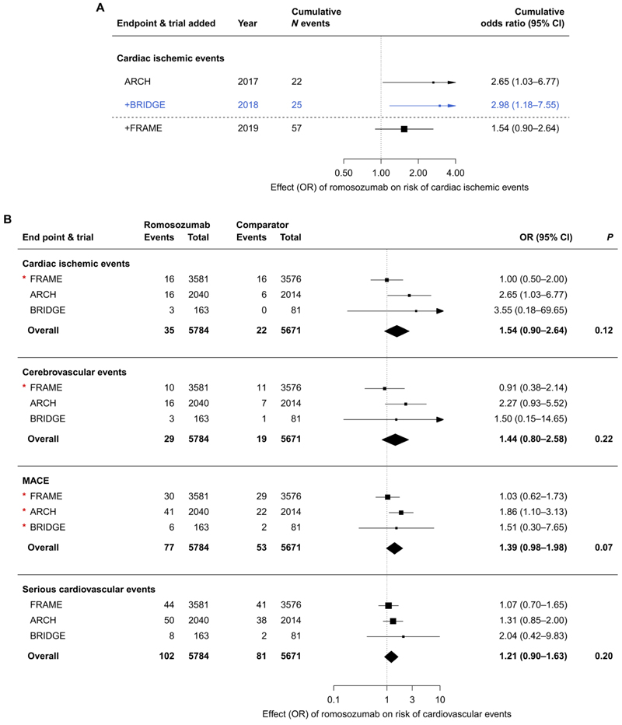

Appendix 2. Summary of HeartScore risk
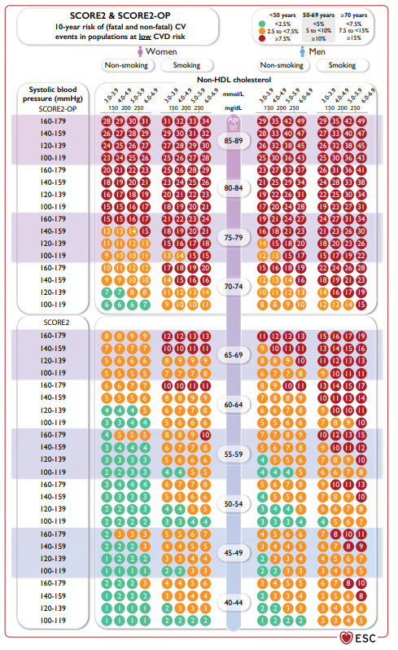
Systematic Coronary Risk Estimation 2 and Systematic Coronary Risk Estimation 2-Older Persons risk charts for fatal and non-fatal (myocardial infarction, stroke) cardiovascular disease. CV = cardiovascular; CVD = cardiovascular disease; SBP = systolic blood pressure; HDL-C = high-density lipoprotein cholesterol; SCORE2 = Systematic Coronary Risk Estimation 2; SCORE2-OP = Systematic Coronary Risk Estimation 2-Older Persons; For apparently healthy people aged 40-69 years, the SCORE2 algorithm is used to estimate 10-year risk of fatal and non-fatal (myocardial infarction, stroke) CVD. For apparently healthy people >_70 years of age, the SCORE2-OP is used. Low-risk countries: Belgium, Denmark, France, Israel, Luxembourg, Norway, Spain, Switzerland, the Netherlands, and the UK (5).

Appendix 3. Correction factors for different ethnic groups*
Multiply the risk estimated using HeartScore by the correction factor below and then compare with the chart in Appendix 2 to see colour categorisation for each age group (5).
- Southern Asian: multiply the risk by 1.3 for people with Indian or Bangladesh ethnicity, and by 1.7 for people with Pakistani ethnicity.
- Other Asian ethnic groups: multiply the risk by 1.1.
- People with Black Caribbean ethnicity: multiply the risk by 0.85.
- People with Black African ethnicity : multiply the risk by 0.7
- People with Chinese ethnicity: multiply the risk by 0.7
*See link for list of ethnic groups

Appendix 4. Diabetic Patients
Patients with diabetes mellitus are at higher risk of cardiovascular events. A separate HeartScore algorithm for those with type-2 diabetes is in development and will be considered for adoption as part of these guidelines once available. Until this point the European Society of Cardiology suggests all patients with diabetes mellitus should be considered high risk (Red category) unless all these criteria are met (5):
- Well controlled
- Diagnosed less than 10 years ago
- No evidence of target organ damage
- No additional atherosclerotic disease risk

Appendix 5. Measures to recommend to a patient with increase cardiovascular risk
Stay active to improve your fitness and develop your muscle strength. The European Society of Cardiology recommends: 150 - 300 min/week of moderate intensity or 75 - 150 min/ week of vigorous intensity aerobic physical activity (6)
Eat a balanced diet including plenty of fresh fruit and vegetables. The NHS provides more information online.
If you smoke, try to stop: to reduce your risk of heart attacks and strokes. If quitting is difficult, you could consider referral for a smoking cessation programme.
Drink in moderation as too much alcohol can damage your heart. Try to follow recommended alcohol levels: no more than 14 units/week for both men and women.
Medication to discuss with your GP:
- Would you benefit from taking a statin to reduce your cholesterol levels? The European Society of Cardiology recommends reducing the LDL-C below 2.6 mmol/L and non-HDL-C <3.4 mmol/L
- Would you benefit from blood pressure medication to reduce your blood pressure? The European Society of Cardiology recommends your systolic BP should be below 130 mmHg if tolerated.

Appendix 6: References
1. Saag KG, Petersen J, Brandi ML, Karaplis AC, Lorentzon M, Thomas T, et al. Romosozumab or Alendronate for Fracture Prevention in Women with Osteoporosis. N Engl J Med. 2017;377(15):1417-27.
2. Cosman F, Crittenden DB, Adachi JD, Binkley N, Czerwinski E, Ferrari S, et al. Romosozumab Treatment in Postmenopausal Women with Osteoporosis. N Engl J Med. 2016;375(16):1532-43.
3. Lewiecki EM, Blicharski T, Goemaere S, Lippuner K, Meisner PD, Miller PD, et al. A Phase III Randomized Placebo-Controlled Trial to Evaluate Efficacy and Safety of Romosozumab in Men With Osteoporosis. The Journal of clinical endocrinology and metabolism. 2018;103(9):3183-93.
4. Bovijn J, Krebs K, Chen CY, Boxall R, Censin JC, Ferreira T, et al. Evaluating the cardiovascular safety of sclerostin inhibition using evidence from meta-analysis of clinical trials and human genetics. Sci Transl Med. 2020;12(549).
5. group SOw, collaboration ESCCr. SCORE2-OP risk prediction algorithms: estimating incident cardiovascular event risk in older persons in four geographical risk regions. Eur Heart J. 2021;42(25):2455-67.
6. Pelliccia A, Sharma S, Gati S, Back M, Borjesson M, Caselli S, et al. 2020 ESC Guidelines on sports cardiology and exercise in patients with cardiovascular disease. Eur Heart J. 2021;42(1):17-96.

