Oliver McGowan Training Summary
Background
The Government has introduced a requirement for Care Quality Commission (CQC) registered service providers to ensure their employees receive learning disability and autism training appropriate to their role. This is to ensure the health and social care workforce has the right skills and knowledge to provide safe, compassionate and informed care to autistic people and people with a learning disability. This requirement is set out in the Health and Care Act 2022.
The Oliver McGowan draft code of practice on statutory learning disability and autism training was published on 27th June 2023. This is currently under consultation, so there may be further changes.
You can visit The Oliver McGowan Mandatory Training on Learning Disability and Autism webpage for further information and updates.

How do I know which Tier my employees need to complete?
Tier 1 of The Oliver McGowan Mandatory Training on Learning Disability and Autism is for people who require general awareness of the support autistic people or people with a learning disability may need.
Tier 2 of The Oliver McGowan Mandatory Training on Learning Disability and Autism is for people who may need to provide care and support for autistic people or people with a learning disability.
Depending on their role, staff may require further capabilities in addition to those covered in the Tier 2 package. It is the responsibility of employers to determine any further capabilities their staff need and to put in place the appropriate provisions.
It is the employers’ responsibility to ensure their staff have the appropriate training for their roles and they will need to advise staff on whether they should complete Tier 1 or Tier 2. Employers can refer to The Oliver McGowan Mandatory Training Tier Guidance.
There are examples given in the Tier guidance. Unfortunately, none of those refers to General Practice settings. The below example provides the closest match.
“In an acute hospital trust, all clinical and support staff may need to complete Tier 2 of The Oliver McGowan Mandatory Training because they may need to provide care and support to autistic people or people with a learning disability. Administrators and scientists who do not have patient-facing roles, such as accountants or microbiologists, may only need to complete Tier 1 of The Oliver McGowan Mandatory Training.”
Based on this scenario, I have interpreted the following applies to General Practice:
All non-patient-facing staff require Tier 1 training (No patient contact)
All clinical & Support staff require Tier 2 training (Those with patient contact)

What training is required?
The training is split into 2 parts for both Tier 1 & Tier 2 staff as shown in the infographic below.
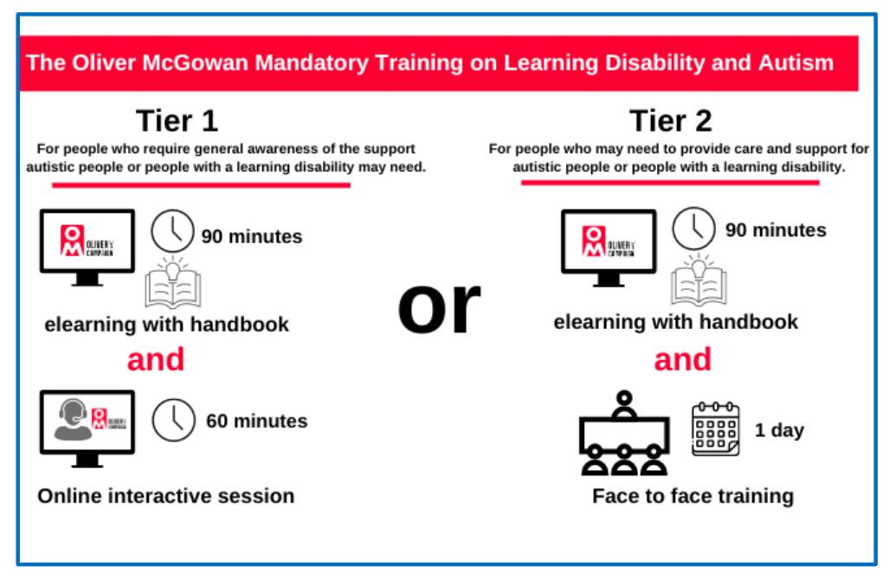

What training is available?
eLearning & Handbook: This is available on eLearning for Health here. This training takes around 90 minutes and ALL staff are required to complete this training.
Tier 1 Online interactive session: The Tier 1 online interactive session will be rolled out once trainer capacity is increased.
Tier 2 Face to Face Training: The Oliver McGowan Tier 2 F2F mandatory training for clinical / patient-facing staff is now available for staff across our ICS to book. Booking links are in the table below.
The following should be noted:
- Training is for clinical and patient-facing health and adult social care staff in BNSSG only.
- The Oliver McGowan e-learning module is a pre-requisite to the Tier 2 training and staff must have completed this prior to booking their space.
- Training sessions have been arranged for an initial 2-month period only. Work is ongoing to confirm further twice-weekly sessions from December onwards.
- There is a maximum of 30 places available at each session. Booking will not be possible once sessions are at capacity.
- Places are currently free of charge.
- Staff must cancel their bookings if they find they are subsequently unable to attend, in order that places can be reallocated.

Session Date | Session Location | Eventbrite Link
03/10/2023 | The Greenway Centre, Doncaster Rd, Bristol BS10 5PY | Oliver McGowan Mandatory Training on Learning Disability & Autism – Tier 2 Tickets, Tue 3 Oct 2023 at 09:30 | Eventbrite
05/10/2023 | The Campus, Highlands Ln, Weston-super-Mare, BS24 7DX | Oliver McGowan Mandatory Training on Learning Disability & Autism – Tier 2 Tickets, Thu 5 Oct 2023 at 09:30 | Eventbrite
10/10/2023 | The Campus, Highlands Ln, Weston-super-Mare, BS24 7DX | Oliver McGowan Mandatory Training on Learning Disability & Autism – Tier 2 Tickets, Tue 10 Oct 2023 at 09:30 | Eventbrite
12/10/2023 | St Monica Trust, The Chocolate Quarter, Trajectus Way, Keynsham BS31 2GJ | Oliver McGowan Mandatory Training on Learning Disability & Autism – Tier 2 Tickets, Thu 12 Oct 2023 at 09:30 | Eventbrite
17/10/2023 | Lower Ground Boardroom, 360 Bristol, Marlborough St, Bristol BS1 3NX | Oliver McGowan Mandatory Training on Learning Disability & Autism – Tier 2 Tickets, Tue 17 Oct 2023 at 09:30 | Eventbrite
19/10/2023 | The Campus, Highlands Ln, Weston-super-Mare, BS24 7DX | Oliver McGowan Mandatory Training on Learning Disability & Autism – Tier 2 Tickets, Thu 19 Oct 2023 at 09:30 | Eventbrite
24/10/2023 | Ridgewood Community Centre, 244 Station Rd, Yate, Bristol BS37 4AF | Oliver McGowan Mandatory Training on Learning Disability & Autism – Tier 2 Tickets, Tue 24 Oct 2023 at 09:30 | Eventbrite
26/10/2023 | St Monica Trust, The Chocolate Quarter, Trajectus Way, Keynsham BS31 2GJ | Oliver McGowan Mandatory Training on Learning Disability & Autism – Tier 2 Tickets, Thu 26 Oct 2023 at 09:30 | Eventbrite
31/10/2023 | The Campus, Highlands Ln, Weston-super-Mare, BS24 7DX | Oliver McGowan Mandatory Training on Learning Disability & Autism – Tier 2 Tickets, Tue 31 Oct 2023 at 09:30 | Eventbrite
02/11/2023 | Kingswood Civic Centre, High St, Bristol BS15 9TR | Oliver McGowan Mandatory Training on Learning Disability & Autism – Tier 2 Tickets, Thu 2 Nov 2023 at 09:30 | Eventbrite
07/11/2023 | Lower Ground Boardroom, 360 Bristol, Marlborough St, Bristol BS1 3NX | Oliver McGowan Mandatory Training on Learning Disability & Autism – Tier 2 Tickets, Tue 7 Nov 2023 at 09:30 | Eventbrite
09/11/2023 | St Monica Trust, The Chocolate Quarter, Trajectus Way, Keynsham BS31 2GJ | Oliver McGowan Mandatory Training on Learning Disability & Autism – Tier 2 Tickets, Thu 9 Nov 2023 at 09:30 | Eventbrite
14/11/2023 | Lower Ground Boardroom, 360 Bristol, Marlborough St, Bristol BS1 3NX | Oliver McGowan Mandatory Training on Learning Disability & Autism – Tier 2 Tickets, Tue 14 Nov 2023 at 09:30 | Eventbrite
16/11/2023 | Avonmouth Community Association, 257 Avonmouth Rd, Bristol BS11 9EN | Oliver McGowan Mandatory Training on Learning Disability & Autism – Tier 2 Tickets, Thu 16 Nov 2023 at 09:30 | Eventbrite
21/11/2023 | Lower Ground Boardroom, 360 Bristol, Marlborough St, Bristol BS1 3NX | Oliver McGowan Mandatory Training on Learning Disability & Autism – Tier 2 Tickets, Tue 21 Nov 2023 at 09:30 | Eventbrite
23/11/2023 | The Campus, Highlands Ln, Weston-super-Mare, BS24 7DX | Oliver McGowan Mandatory Training on Learning Disability & Autism – Tier 2 Tickets, Thu 23 Nov 2023 at 09:30 | Eventbrite
28/11/2023 | Kingswood Civic Centre, High St, Bristol BS15 9TR | Oliver McGowan Mandatory Training on Learning Disability & Autism – Tier 2 Tickets, Tue 28 Nov 2023 at 09:30 | Eventbrite
30/11/2023 | Avonmouth Community Association, 257 Avonmouth Rd, Bristol BS11 9EN | Oliver McGowan Mandatory Training on Learning Disability & Autism – Tier 2 Tickets, Thu 30 Nov 2023 at 09:30 | Eventbrite
05/12/2023 | Lower Ground Boardroom, 360 Bristol, Marlborough St, Bristol BS1 3NX | Oliver McGowan Mandatory Training on Learning Disability & Autism – Tier 2 Tickets, Tue 5 Dec 2023 at 09:30 | Eventbrite

Kim Ball, Director of Nursing, Avon LMC.
16/08/2023

