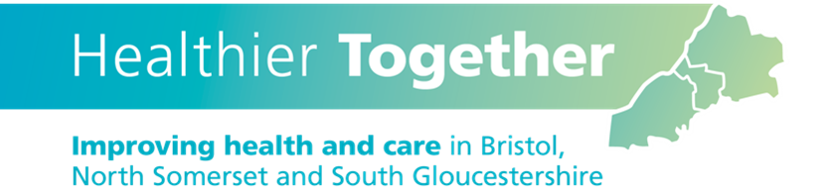

**BNSSG Datix ‘Contact Us’ Portal Annual Newsletter 2022-23**

What a difference a year makes. After making improvements throughout 2021/22 to our Datix event reporting system and continually sharing news highlights throughout the year the system has seen an incredible 740 primary care ‘contact us’ events reported in the year, a 30% increase over previous year. And only 8 practices across the region did not report any concerns.

**Why report to the ICB?** Sharing your concerns and reporting patient safety events has helped us to improve pathways and patient experience. (See ‘You Said – Our Actions’ section)

Reporting tool link - <https://bnssg-datix.scwcsu.nhs.uk/index.php?form_id=14&module=INC>

**What do we know through your shared reports?**

Most reports shared seem to fit under three key themes which when broken down further, highlights some areas for improvement:

* 37% of reports were pertaining to a **discharge problem**.
  + Timely receipt of discharge letters.
  + Medication errors on discharge letter.
  + Inaccurate information on the discharge letter.
  + FIT note not sufficiently provided.
* 33% of reports were pertaining to **follow up care** for the patient.
  + Onwards care not implemented.
  + Tests undertaken by Secondary care not reviewed/followed up.
  + Request for GP to follow up care.
* 21% of reports were pertaining to potential **delays to care**.
  + Difficulties arranging patient review/appointments/admissions.
  + Test results not received/available on reporting platform.
  + Two week wait (2WW) referral communication concerns.

**2023/24 aims.**

With the introduction of the [Patient Safety Strategy](https://www.england.nhs.uk/patient-safety/the-nhs-patient-safety-strategy/), the release of the [Patient Safety Incident Response Framework (PSIRF)](https://www.england.nhs.uk/patient-safety/incident-response-framework/)and not forgetting our new integrated way of working we are expecting to see huge changes and challenges in the way we work. The more concerns you report to us on Datix the better we become at ensuring the focus is on the patients’ needs and the smoother the transition of care between different settings.

**You Said – Our Actions**

***Inappropriate request to follow up patient test results/care***

***Failure to receive a timely discharge summary.***

‘**Discharge summaries, whilst a contractual requirement ’remains a leading theme identified through reports received. By talking with our partner organisations, we obtained the following intelligence for improvements being made.**

**UHBW** undertook a system wide IT review of data transfer to Primary Care. The review identified that discharge letters were not always sent from Same Day Emergency Care (SDEC). Additional resources are now in place to ensure that a Discharge Summary is sent for all patients attending SDEC. Work was also undertaken to prevent duplication copies being sent out.

**NBT** – Phase 2 of the Care Flow Digital Transformation Programme is now fully embedded standardising the electronic Patient Records ensuring timely electronic distribution of the discharge summary process.

IT remains the biggest barrier where implemented systems do not link together so reporting remains challenging to get it right.

***FIT notes not being issued in Secondary Care***

An issue was identified that pathology results were not being received in North Somerset by EMIS. UHBW investigated this thoroughly and it was later identified as an issue with EMIS and was rectified by BNSSG ICB and EMIS developers.

The ICB Medication Optimisation Team has raised awareness of safety measures needed when switching patients from one DOAC to another DOAC. Anticoagulant counselling documents have been updated on Remedy for all prescribers to be aware of.

Datix reports are shared with the ICB Medication Safety Teams as well as with the appropriate partner organisation. This workstream is led through the Medicines Optimisation Reporting with improvement areas identified.

***Inaccurate medication information on Discharge* Summary**

The team firstly check the validity of this report by consulting with the BNSSG Remedy guidance as guidance continues to evolve and change. Check to ensure the patient has continued their health journey. Share with partner organisation for embedding learning.

FIT Notes can now be issued and certified by more staff members within the Acute trusts including Nurses, Pharmacists, Physiotherapists and Occupational therapists.

This was communicated internally through safety briefings.

***Medication concerns including Prescribing, monitoring of Double DOACs (Direct Oral Anticoagulants)***

***No pathology results being communicated to GP Surgeries.***

***EMIS and ICE clash***