**Structured Medication Reviews**

**Introduction**

In May 2020 NHS England (NHSE) and NHS Improvement (NHSI) published a call to action for [Care homes](https://www.england.nhs.uk/coronavirus/wp-content/uploads/sites/52/2020/03/COVID-19-response-primary-care-and-community-health-support-care-home-residents.pdf) in response to the COVID-19 pandemic. It describes the medicines and pharmacy contribution to the work and sets out how teams should collaborate across the NHS system. From 1st October 2020, one of the requirements of the Direct Enhanced Service (DES) Specification for Primary Care Network (PCN) is to identify and prioritise patients that will benefit from a Structured Medication Review (SMR) [PCN DES](https://www.england.nhs.uk/wp-content/uploads/2020/03/network-contract-des-specification-pcn-requirements-entitlements-2020-21.pdf).

**Which patients to undertake a SMR?**

* Patients in care homes –weekly MDT ‘home round’ for residents should be prioritised according to need.
* Patients with complex and problematical polypharmacy ≥ 10 medicines and ≥ 75 years
* Patients prescribed medicines commonly associated with medication errors –defined by the 20 [NHSBSA Indicators](https://www.nhsbsa.nhs.uk/sites/default/files/2019-08/Medication%20Safety%20-%20Indicators%20Specification%20%28Aug19%29.pdf).
* Patient presenting with an adverse event, or medicine not controlling their symptoms.
* Patients with [severe frailty](https://www.england.nhs.uk/ourwork/clinical-policy/older-people/frailty/efi/) eFI >0.36, who are particularly isolated, housebound or who have had recent hospital admissions and/or falls e.g. within the last 6 months.
* Patients using potentially addictive pain management medication
* Patients with complex Long-Term conditions eg asthma, COPD, the Stop Over Medication for People with learning disabilities or autism programme (STOMP);
* Inappropriate use of antibiotics

**Who can undertake an SMR?**

Only trained clinicians working within their sphere of competence can undertake an SMR. They must be carried out by clinical pharmacists who have completed – or who are enrolled on the [Primary Care Pharmacy Education Pathway (PCPEP)](https://www.cppe.ac.uk/career/pcpep/pcpep-training-pathway) or a similar training programme that includes training on shared decision-making, as well as independent prescribing and advanced assessment and history taking skills, to enable a holistic view of a patient’s medication. All pharmacists enrolling on PCPEP will undergo an assessment of prior learning and experience so training isn’t duplicated. Nationally they are exploring credentialing existing general practice pharmacists so that their skills and experience can be recognised. Currently, pharmacy technicians do not meet the criteria for undertaking SMRs, although they have a key role in supporting other clinicians to do so as part of the PCN multi-professional team.

GPs can undertake SMRs and suitably qualified advanced nurse practitioners (ANPs) (working within their sphere of competence). It is expected/required that any ANPs who undertake SMRs are experienced in working in a generalist setting and able to take a holistic view of a patient’s medication. A SMR is not considered complete until qualified consideration has been given to all the patient’s medication; clinicians should be encouraged to collaborate with colleagues across the PCN and elsewhere, including acute care, and take a multidisciplinary approach to managing complex situations.

**How many SMRs need to be undertaken within a PCN?**

This is determined and limited by PCN clinical pharmacist capacity, demonstrating all reasonable on-going efforts to maximise that capacity and to prioritise high risk patients.

**Medication Review**

Preparation should be undertaken prior to seeing the patient, looking at medications indications (if not obvious), blood/monitoring for medications for safe use, common side effects/ADR’s, NNT evidence, ACB score.

BNSSG have produced a comprehensive [Medication Review Tool for Polypharmacy in th*e* Elderly](https://remedy.bnssgccg.nhs.uk/media/4131/bnssg-primary-care-medication-review-tool-march-2020-vs-18docx-1.pdf). This contains information on assessing frailty, shared decision making, anticholinergic burden and deprescribing.

The guide links to useful tools to help undertake a medication review e.g. [No Tears Tool](https://www.bmj.com/content/329/7463/434), [7 steps medication review](http://www.polypharmacy.scot.nhs.uk/polypharmacy-guidance-medicines-review/for-healthcare-professionals/principles/the-7-steps-medication-review/),  [STOPIT Tool](https://www.sps.nhs.uk/repositories/screening-tool-for-older-peoples-potentially-inappropriate-treatments-stopit-medication-review-tool/), [STOPP START Tool](https://academic.oup.com/ageing/article/44/2/213/2812233), [BNSSG STOPP START Tool](https://remedy.bnssgccg.nhs.uk/formulary-adult/local-guidelines/17-polypharmacy/) and highlights specific drugs to review. In addition, clinicians need to work with BNSSG CCG to optimise the quality of prescribing in reducing the inappropriate use of antimicrobials and nationally identified [low value medicines](https://www.england.nhs.uk/medicines-2/items-which-should-not-be-routinely-prescribed/). For asthma and COPD patients a focus should also include the [environmental impact of inhalers](https://remedy.bnssgccg.nhs.uk/formulary-adult/local-guidelines/3-respiratory-system-guidelines/).

The guidance also outlines how PCNs should work with community pharmacies to connect patients appropriately to the New Medicine Service which supports adherence to newly prescribed medicines.

**Risk Stratification**

Within each PCN/Practice, tools can be utilised by healthcare professionals to identify those patients who may benefit most from a SMR. Wessex Academic Health Science Network (AHSN) have also developed some helpful training tools and links to the [NHS BSA Polypharmacy Prescribing Comparators](https://wessexahsn.org.uk/projects/323/nhs-bsa-polypharmacy-prescribing-comparators).

PINCER searches, Eclipse Live/Radar red/amber alerts, EPACT2 and Arden searches are also helpful. In addition, high risk patients can be identified from recent hospital discharges and those identified at a Care home MDT ward round. (Refer to Appendix 1 for more information).

**Delivering Medication Reviews**

[Shared decision](https://www.england.nhs.uk/wp-content/uploads/2019/01/shared-decision-making-summary-guide-v1.pdf) making is part of the NHS Long Term Plan and ensures patients have choice and are empowered to engage with their medicines. Decisions should be based on ‘what matters’ most to them. Prior to the review, patients need information explaining the benefits of the medication review and what to expect (Appendix. Patients should bring all their mediations in with them if attending a face to face consultation or have them in front of them if having a remote consultation.

With the Covid-19 pandemic, it is likely that consultations will be undertaken remotely. Information has been produced on undertaking remote consultations by [NHSE](https://www.england.nhs.uk/wp-content/uploads/2020/01/online-consultations-implementation-toolkit-v1.1-updated.pdf) and the [RPS](https://www.rpharms.com/resources/pharmacy-guides/coronavirus-covid-19/watch-and-listen#podcasts)

Use a checklist: [CONSULT](https://www.pharmaceutical-journal.com/download?ac=1080450)

|  |
| --- |
| **C**onsider remote consultation or not? |
| **O**rganise and test technology |
| **N**ecessary requirements to hand |
| **S**tart the consultation purposefully - Agree an agenda, manage expectations re time |
| **U**ndertake the review –Review tools |
| **L**isten and agree next steps –Shared decision making, NNT/NNH |
| **T**erminate appropriately – Summarise, safety netting, ensure remote consultation has been terminated. |

**Documentation**

An SMR emis template (appendix 5) is available to help ensures key issues are covered and guide read codes. Please ensure that the appropriate SNOMED code is used: 1239511000000100 Structured medication review (procedure)

It is vital that information is clearly documented with any decisions made and subsequent follow up.

**Additional Useful resources**

1. **Care Home resources:**

**-**BNSSG guidelines: https://remedy.bnssgccg.nhs.uk/formulary-adult/local-guidelines/17-other/

-SPS Care Home resource hub: https://www.sps.nhs.uk/home/services/care-home-resource-hub/

-MUS webinar-Care Homes: Structured Medication reviews through remote consultations during the COVID- 19 pandemic: <https://www.sps.nhs.uk/meetings/monthly-mus-webex-care-homes-structured-medication-reviews-through-remote-consultations-during-the-covid-19-pandemic/>

1. **Structured Medication Reviews:**

PrescQipp – Structured Medication Review webinar

1. **National Institute for Health and Clinical Excellence (NICE):**Medicines optimisation: the safe and effective use of medicines to enable the best possible outcomes. (NG5) 2015. <https://www.nice.org.uk/guidance/ng5>
2. **Medicine Safety Portal, Safer prescribing for primary care:** https://www.medicinesafety.co.uk/2020/04/medicines-safety-e-learning-index.html

**Appendix 1 Risk Stratification Tools**

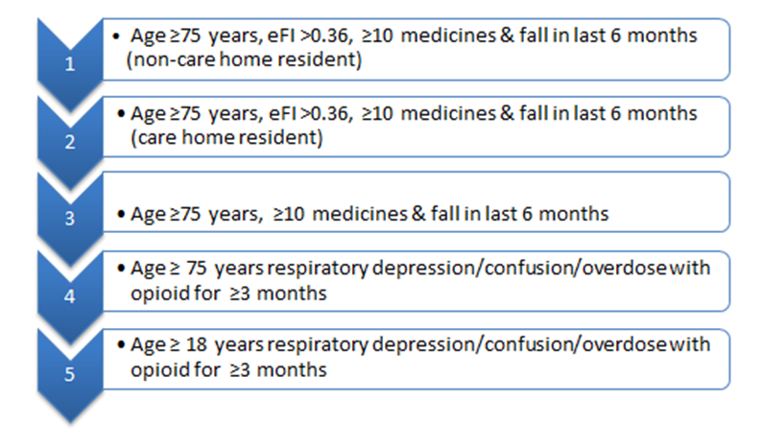

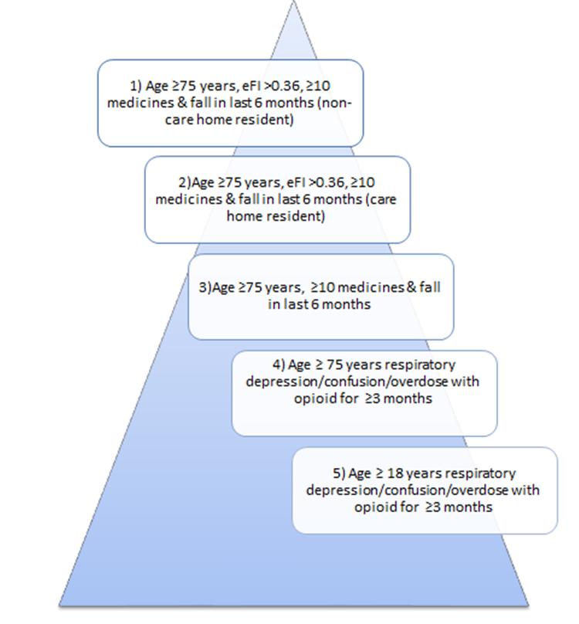

**PINCER**

This is a proven pharmacist-led IT-based intervention to reduce clinically important medication errors in primary care. The intervention comprises:

1. Searching GP computer systems to identify patients at risk of potentially hazardous prescribing using a set of prescribing safety indicators
2. Pharmacists, specifically trained to deliver the intervention, providing an educational outreach intervention where they meet with GPs and other practice staff to discuss the search result, agree an action plan for reviewing patients identified as high risk and pharmacist (and pharmacy technicians) working with, and supporting, general practice staff to implement the agreed action plan

**ECLIPSE LIVE/Radar**

SMR Live Introductory video: <https://www.nhspathways.org/nhspathways/members/SMR/videos/smrintroduction.mp4>

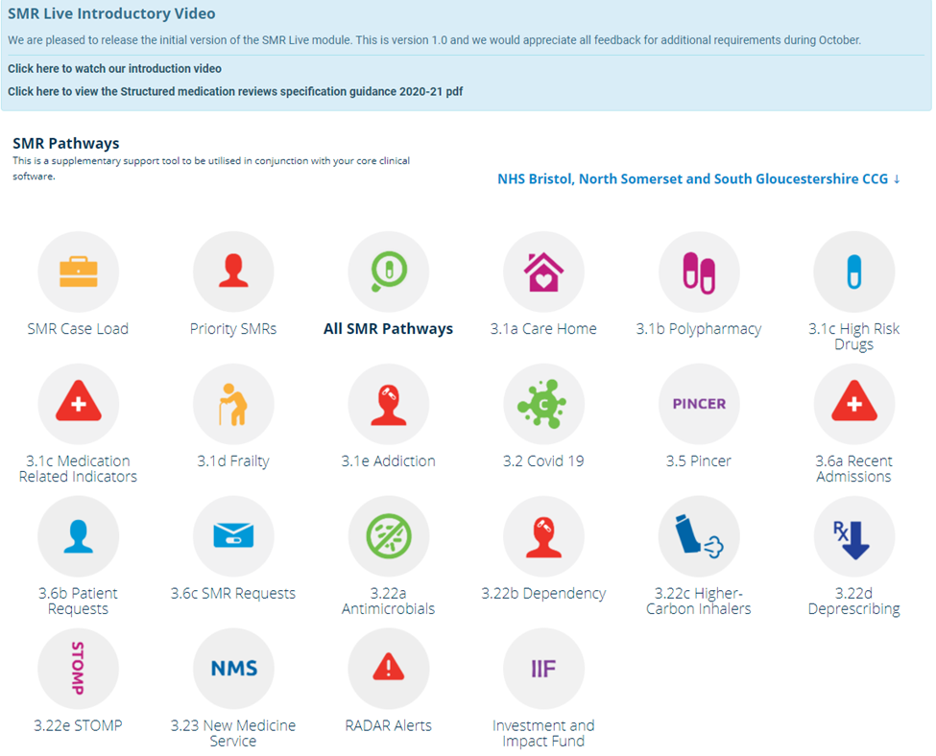

Eclipse Live allows risk stratification in three main ways identifying which patients are:

1. At highest risk of admission.

2. Overdue for screening.

3. At risk from their medications.

Patients are risk stratified according to the number of medicines they are prescribed, high risk medicines, potentially addictive medicines, anticholinergic burden, Frailty, Learning disability and admissions. Please note we are not able to access admission data within BNSSG at present but aim to do this in future. Patients with an SMR score >10 are highlighted within each practice so patients with the highest score should be reviewed first

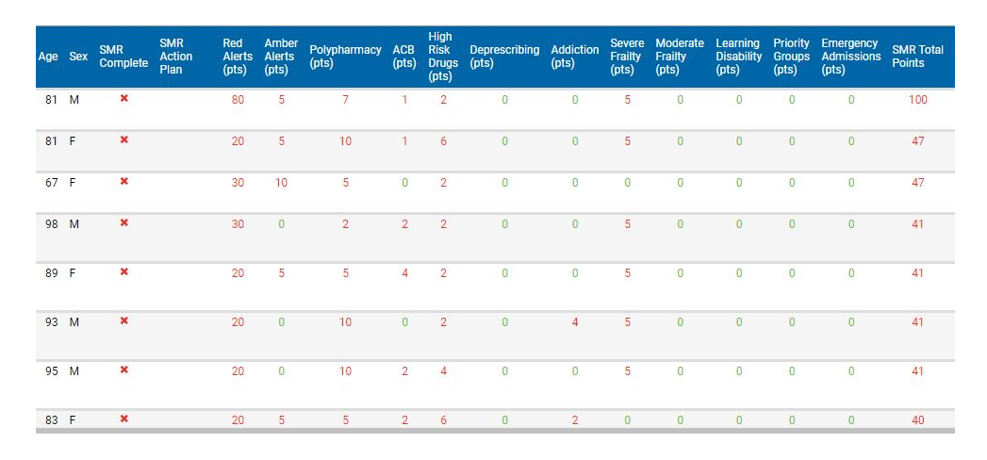

The SMR Live tool is designed to be supplementary to and be used alongside the clinical systems. As part of this the action plan insights can be saved and attached into the clinical system. Eclipse shows the vast majority of patients however it won`t show patients who have chosen to opt out of data sharing.

**BNSSG CCG locally developed Searches**



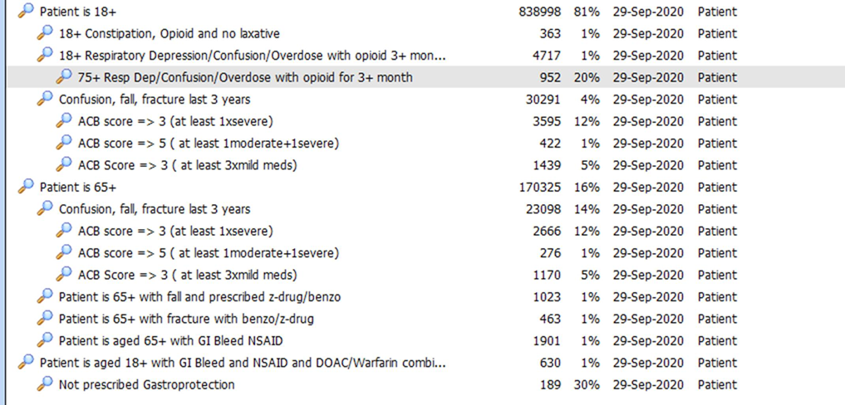

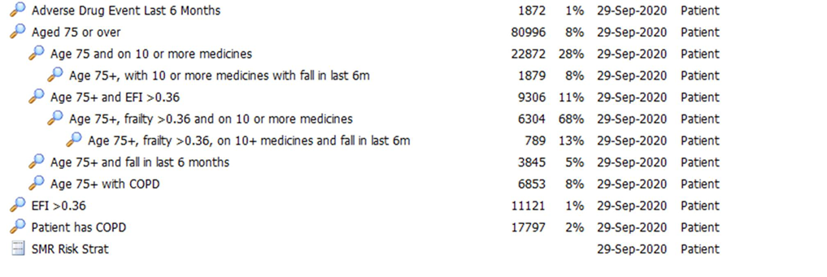

**Appendix 2 Patient Information Leaflet**

**Patient Information on Medication Reviews**

**What is a medication review?**

A medication review is a meeting or video/ phone call with a health care professional to review and discuss your medicines. This is helpful for patients who take a lot of medication. Sometimes this may be referred to as a Polypharmacy review. Polypharmacy means using a large number of medications. We want to support patients to be involved in making decisions about their medicines. It is an opportunity for you to ask questions and find out more about your medicines and check that you are getting the best from your medicines.

**Why do I need a medication review?**

Medicines are prescribed to treat symptoms or diseases, however sometimes your condition changes. When you are prescribed a new medicine you should know

* Why you have been prescribed the medicine and how to take it
* Possible side effects
* How long to take the medicine for
* To check each medicine is safe to take in combination with your other medicines

Your health care professional wants to check that the medicine is effective, that you’re on the right dose and it isn’t causing any problematic side-effects.

**What happens at a medication review?**

The review is confidential and will involve gathering information from you and your medical record. You may also be asked some questions relating to the medicines you take, for example:

* Are you taking all your medicines?
* Do you know why you have been prescribed medicines?
* Can you take/use the medicine properly?
* Are you having any side effects from any of your medicines?
* Do you have any concerns about your medicines?
* Do you take or use any other medicines that you buy?

The health care professional may suggest some changes to your medicines using the best available evidence, but you will be involved in the decision-making process.

**What should I bring to my medication review?**

Please bring/ have in front of you all medicines that you are taking that have been prescribed by your GP practice. Also bring/have in front of you any medicines you buy from the pharmacy, health shop or supermarket including herbal or homeopathic medicines, creams, painkillers, eye drops, nasal sprays, and vitamins.

You may want to think about any questions, concerns or suggestions you may have about your medicines. If someone helps you take your medicines you are welcome to have them with you.

**Questions you may want to ask at your medication review**

* What is the medicine for, what does it do?
* Why is it important to take the medicine?
* What other treatment options are available?
* How and when do I take it and how long for?
* What are the side-effects?
* How can I tell if the medicine is helping? What should I do if I forget to take it and miss a dose?
* What should I do if I become ill whilst taking it?
* Where do I go for information about my medicine?

**You can write your own questions and concerns here to bring to your review:**

**Further Information:**

What happens after my medication review?

You will be informed of any changes agreed to at the medication review

The medicines you are prescribed may be changed but only with your agreement

A summary of the meeting will be recorded in your medical records

Where can I get more information?

For further information about your medicines, please contact:

* Your GP Surgery
* Your community pharmacy (chemist)
* NHS Choices website: <https://www.nhs.uk/>
* Polypharmacy App <https://apps.apple.com/gb/app/polypharmacy-guidance/id1072829127>

Produced by Polypharmacy STP group BNSSG March 2020

Based on NHS Scotland Polypharmacy (Medicines) Review: Information for Patients and Carers

**Appendix 3 Bringing SMR all together presented by SPS**



**Appendix 4: Nina Barnett –Patient Centred polypharmacy process.**

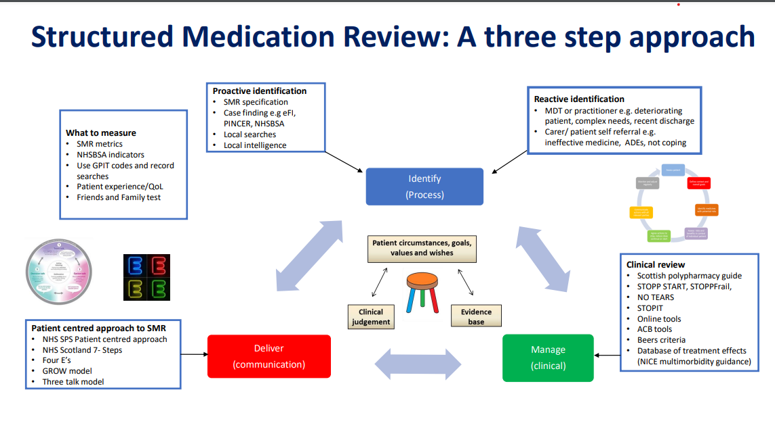

**Appendix 5: Emis Template**



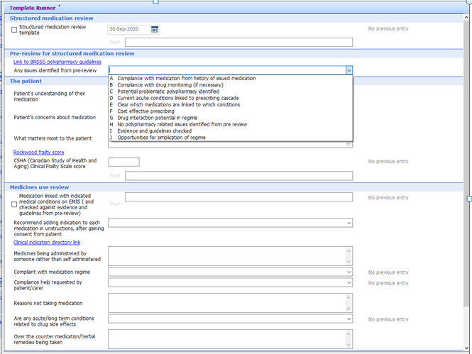  


**Appendix 6:**

**Structured Medication Review (SMR) Pack:**

**Patients Prescribed Dependence Forming Medications**

The table below highlights some documents and resources that may be useful when conducting SMRs to *optimise the quality of prescribing for medicines which can cause dependency.*

|  |  |  |
| --- | --- | --- |
| **Document** | **About** | **Useful links** |
| **Key Documents** | | |
| PHE Dependence and withdrawal associated with some prescribed medicines (2019) | PHE published a review of the evidence for dependence on, and withdrawal from, prescribed medicines in adults who have non-cancer pain, anxiety, insomnia or depression:**benzodiazepines**; **z-drugs**; **gabapentin** and **pregabalin**, **opioids for chronic non-cancer pain; antidepressants.** | <https://assets.publishing.service.gov.uk/government/uploads/system/uploads/attachment_data/file/829777/PHE_PMR_report.pdf> |
| PrescQIPP Bulletin - Dependence Forming Medications (April 2020) | Provides an overview of potential Dependence Forming Medications (DFMs) and signposts to PrescQIPP resources which support medicines optimisation projects in this area. | <https://www.prescqipp.info/our-resources/bulletins/bulletin-256-dependence-forming-medications/> |
| PrescQIPP Bulletin - Appropriate and cost-effective prescribing of hypnotics and anxiolytics (April 2020) | Reviews current evidence and offers advice on managing new patients and chronic hypnotic users. | <https://www.prescqipp.info/our-resources/bulletins/bulletin-258-hypnotics/> |
| **Local Guidance** | | |
| BNSSG Pharmacological Treatment of Adult Chronic (Non-Cancer) Pain 2019 |  | <https://remedy.bnssgccg.nhs.uk/media/3203/bnssg-chronic-pain-guidelines-2019.pdf> |
| BNSSG Remedy website - Bristol Shared Care |  | <https://remedy.bnssgccg.nhs.uk/adults/drug-and-alcohol-misuse/bristol-shared-care/> |
| BNSSG Benzodiazepine and Z-drug Prescribing supportive document |  | <https://remedy.bnssgccg.nhs.uk/formulary-adult/local-guidelines/4-nervous-system-guidelines/> |
| **National Guidance** | | |
| Faculty of Pain Medicines - Opioids Aware  Patient information leaflets | Provides the information to support a safe and effective prescribing decisions around opioid prescribing  Faculty of Pain Medicine has produced patient information leaflets on medications and interventions commonly used to treat persistent pain | <https://fpm.ac.uk/opioids-aware>  https://fpm.ac.uk/about-pain-medicine-patients-relatives/patient-information-leaflets |
| Royal College of General Practitioners - Top Ten Tips: Dependence Forming Medications | Outlines the key issues to consider when prescribing dependence forming medications | <https://www.rcgp.org.uk/clinical-and-research/resources/a-to-z-clinical-resources/dependence-forming-medications.aspx> |
| BMA - Supporting individuals affected by prescribed drugs associated with dependence and withdrawal. | Note section on Prescription and Elicit Drugs | <https://www.bma.org.uk/what-we-do/population-health> |
| **Draft** NICE guideline ‘Chronic pain: assessment and management’ |  | <https://www.nice.org.uk/guidance/GID-NG10069/documents/draft-guideline> |
| **Practice/PCN/CCG Benchmarking – resources which can be used for SMR risk stratification** | | |
| Openprescribing.net |  | https://openprescribing.net/ |
| Eclipse Live |  | http://www.nhspathways.org |
| EMIS searches | Searches to identify appropriate cohorts of patients for this SMR:   1. Opioids with morphine dose >120mg or equivalent 2. SMR Risk Stratification Medicines Safety Indicator searches (e.g. +18 years + respiratory depression/confusion/overdose with opioid > 3 months |  |
| PresQipp searches | Dependence Forming Medications (DFM) pack searches:   1. DFM hypnotics search more than 3 months 2. DFM hypnotics search not ordered within last 6 months 3. DFM nitrazepam search 4. DFM gabapentanoids for more than 3 months 5. DFM strong opioid analgesics for more than 3 months 6. DFM weak opioid analgesics for more than 3 months 7. DFM antidepressants for > 6 months 8. DFM co-prescribing for > 3 months |  |
| **Webinars** | | |
| PrescQIPP – Minimising Inappropriate Prescribing of Fentanyl IR (and other opioids/gabapentanoids) (Feb 2020) | Linda Lord, Chief Pharmacist, NHS West Suffolk CCG presents a webinar which covers the strategies used in West Suffolk for reducing inappropriate prescribing of fentanyl IR. | <https://www.prescqipp.info/our-resources/clinical-webinars/lpp-masterclass-fentanyl-ir/> |
| PrescQIPP – Opioid Prescribing in Chronic Pain (July 2019) | Highlights resources available to support the review and reduction of opioid prescribing in chronic pain. | <https://www.prescqipp.info/our-resources/clinical-webinars/opioid-prescribing-in-chronic-pain/> |
| **Other resources** | | |
| PrescQIPP Pain Webkit | Brings together all the PrescQIPP Pain resources | <https://www.prescqipp.info/our-resources/webkits/pain/> |