

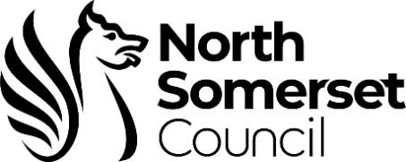

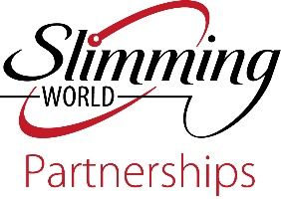

Dear Patient,

Your doctor, practice nurse or health care professional has suggested you would like to join the North Somerset **Slimming World on Referral** service. This service is designed to support you to lose weight.

Losing weight can significantly benefit your health and wellbeing, so it’s great that you would like to join the service. North Somerset Council is working in partnership with Slimming World to offer a programme of support to help you reach a healthier weight.

**About the Slimming World on Referral programme:**

Slimming World offers weekly group support to help you make gradual changes towards a healthy lifestyle.

The programme is FREE for a duration of 12 sessions of weekly support (funded by North Somerset Council) to residents:

* with a body mass index (BMI) equal to 30 or more
* with a body mass index (BMI) equal to 28 or more with a comorbidity, or from Black Caribbean, Black African and Asian ethnic groups
* aged 16 and over

After the initial funded 12 weeks you will be required to fund sessions yourself, however once your reach your target weight you are invited to attend sessions free of charge!

**What does the programme involve?**

A food optimising eating plan is used and is based around satisfying your appetite with healthy everyday foods like fruit and vegetables, pasta, potatoes, eggs, fish, lean meat and chicken so that you never go hungry. It’s a long-term plan, not a quick fix, so no food is banned and whatever your favourite treat is, you can still enjoy it in moderation.

Motivating you to become more active gradually, when you feel ready, is Slimming World’s optional Body Magic programme. It works by redefining what is seen as activity so that anything that gets you moving more, from washing the car to walking the dog, is rewarded and counts towards your weekly total.

As a member, you choose the target weight that you feel happy with and are motivated and encouraged in hour long weekly meetings to share experiences, recipes and ideas with your fellow slimmers in a warm, supportive environment. Research shows this is crucial to weight loss success and, once you reach your target weight, you can attend for free.

Groups are led by trained Slimming World Consultants, all of whom are former members and have lost weight on the plan themselves. Your weight always remains confidential and your weight losses and gradual changes towards a healthy lifestyle are celebrated.

For further information about Slimming World visit: [www.slimmingworld.co.uk](http://www.slimmingworld.co.uk), search via post code to find your nearest group.

**Register for your FREE 12 weeks of support now!**

To start your registration for 12 weeks FREE at Slimming World, please call

01773 483247.

Once you have registered for support you can expect to receive your vouchers within 7 to 10 days providing you are eligible. You will then have 4 weeks to activate the vouchers allocated to you.

**Updated: December 2022**