Quality Outcomes Framework (QOF) Quality Improvement (QI) Module 2022-23 Practice Support Pack:
Patients Prescribed Dependence Forming Medications (DFM)
The overarching aim of this QI module is to lead to improvements in relation to the following aspects of prescribing safety:
• Use of non-pharmacological alternatives rather than initiation of DFMs in line with best evidence and guidance.
• Structured medication reviews of patients taking 120mg oral morphine equivalent (OME) or more for chronic pain.
• Structured medication reviews where there is polypharmacy or inappropriate use of dependence forming medications.
Practices will need to undertake the following steps:
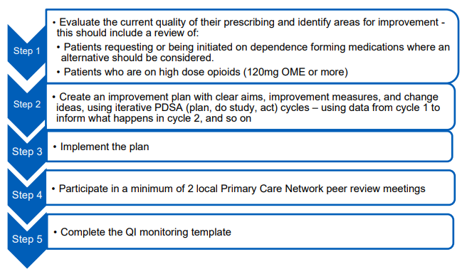
NICE Guidance NG215 highlights when withdrawing a dependence-forming medicine or antidepressant should be discussed;
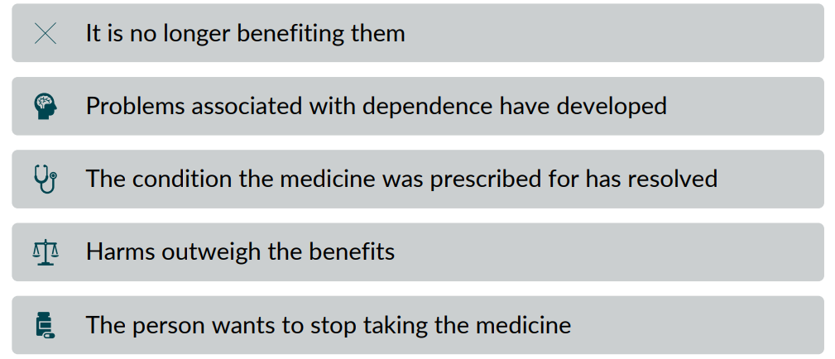

It also highlights the importance of making shared decisions about withdrawing medicines
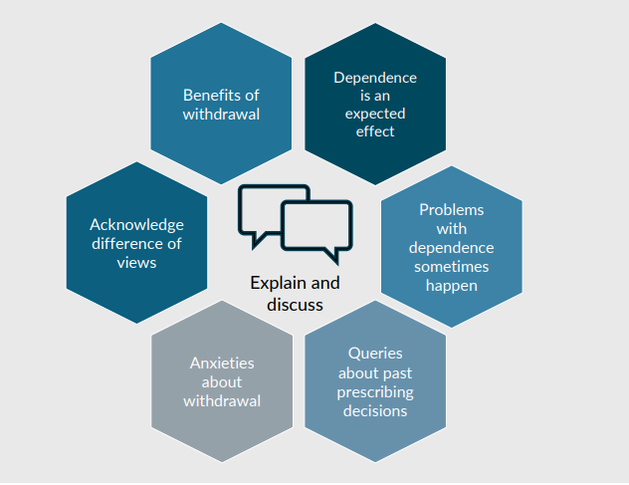
The table below highlights some documents and resources that may be useful to support practices with the QOF Quality Improvement module Prescription Drug Dependency work. Please note that consideration should be given to patients with life-limiting diseases and should be discussed with relevant care providers before practices consider addressing their prescribed dependence forming medicines in that patient group.
Document | About | Useful links
Quality Outcomes Framework (QOF)
QOF Guidance 2022/23 | Guidance on the interpretation and verification of  the QOF indicators for 2022/23 in England | https://www.england.nhs.uk/wp-content/uploads/2022/03/B1333_Update-on-Quality-Outcomes-Framework-changes-for-2022-23_310322.pdf

QOF QI – Prescription Drug Dependency Reporting Template |  | https://www.england.nhs.uk/wp-content/uploads/2022/03/B1333_Update-on-Quality-Outcomes-Framework-changes-for-2022-23_310322.pdf

Data –
Practice/PCN/CCG Benchmarking
Openprescribing.net | Every month, the NHS in England publishes anonymised data about the drugs prescribed by GPs. But the raw data files are large and unwieldy, with more than 700 million rows. Openprescribing making it easier for GPs, managers and everyone to explore - supporting safer, more efficient prescribing. Data includes:  - Prescribing of Opioids (total oral morphine equivalence)  - Prescribing of pregabalin  - High dose opioids per 1000 patients  - Prescribing of gabapentin and pregabalin (Defined Daily Dose, DDD)  - High dose opioid items as percentage of regular opioids  - Anxiolytics and Hypnotics: Average Daily Quantity per Item | https://openprescribing.net/
Eclipse Live | The SMR module area 3.1e ‘Addiction’ which lists all patients prescribed Gabapentin, Pregabalin, Opiates, Z-drugs and Benzodiazepines. Eclipse will then prioritise those in greatest need of review. | http://www.nhspathways.org

EMIS searches | Searches to identify appropriate cohorts of patients for this SMR:  - Opioids with morphine dose >120mg or equivalent  - SMR Risk Stratification Medicines Safety Indicator searches (e.g. +18 years + respiratory depression/confusion/overdose with opioid > 3 months
PresQipp searches | Dependence Forming Medications (DFM) pack searches:  - DFM hypnotics search more than 3 months  - DFM hypnotics search not ordered within last 6 months  - DFM nitrazepam search > 1 month  - DFM gabapentanoids for more than 3 months  - DFM strong opioid analgesics for more than 3 months  - DFM weak opioid analgesics for more than 3 months  - DFM antidepressants for > 6 months  - DFM co-prescribing for > 3 months

ePACT2 Opioid Prescribing Comparators Dashboard | A new Opioid Prescribing Comparators dashboard which has been developed in collaboration with Wessex AHSN.  The dashboard presents a new piece of work that will allow users to highlight variation and to support the monitoring of opioid prescribing.  The dashboard is able to identify those patients newly prescribed opioids, and those taking for more than 3 months but less than 6 months. NHS BSA can provide lists of NHS patient numbers to practices, which can be reviewed and triaged to remove those receiving opioids for end of life or cancer-based pain.  EPACT2 are running a series of webinar sessions introducing the new dashboard and all of the functionality. If you’d like to attend a session, please use their online booking calendar to register.  NHS BSA and Wessex AHSN Opioid Prescribing Comparators Webinar held on Tuesday, 21 June. | https://www.nhsbsa.nhs.uk/access-our-data-products/epact2  https://outlook.office365.com/owa/calendar/NHSBSAePACT2trainingwebinars@nhsbsa.nhs.uk/bookings/  https://vimeo.com/722549654/c5b9af4c0a
National Guidance
Faculty of Pain Medicines - Opioids Aware  Patient information leaflets | Provides the information to support a safe and effective prescribing decision around opioid prescribing  Faculty of Pain Medicine has produced patient information leaflets on medications and interventions commonly used to treat persistent pain | https://fpm.ac.uk/opioids-aware  https://fpm.ac.uk/about-pain-medicine-patients-relatives/patient-information-leaflets
Royal College of General Practitioners - Top Ten Tips: Dependence Forming Medications | Outlines the key issues to consider when prescribing dependence forming medications
BMA - Supporting individuals affected by prescribed drugs associated with dependence and withdrawal. | Note section on Prescription and Elicit Drugs | https://www.bma.org.uk/what-we-do/population-health
NICE Guidelines [NG 193]: Chronic pain (primary and secondary) in over 16s: assessment of all chronic pain and management of chronic primary pain April 21 | These are the updated guidelines published April 2021. | https://www.nice.org.uk/guidance/ng193
NICE CKS Chronic Pain, April 2021 |  | https://cks.nice.org.uk/topics/chronic-pain/
NICE Guidelines [NG215]  Medicines associated with dependence or withdrawal  symptoms: safe prescribing and withdrawal management  for adults | These new guideline covers general principles for prescribing and managing withdrawal from opioids, benzodiazepines, gabapentinoids, Z-drugs and antidepressants in primary and secondary care. This guidance highlights the importance of supporting patients on these medicines, starting and reviewing these medicines as well as making shared decisions about withdrawal. | https://www.nice.org.uk/guidance/ng215
CQC - The safer management  of controlled drugs  Annual update 2020 |  | https://www.cqc.org.uk/publications/themes-care/safer-management-controlled-drugs-annual-update-2020
PHE Dependence and withdrawal associated with some prescribed medicines (2019) | PHE published a review of the evidence for dependence on, and withdrawal from, prescribed medicines in adults who have non-cancer pain, anxiety, insomnia, or depression: benzodiazepines; z-drugs; gabapentin and pregabalin, opioids for chronic non-cancer pain; antidepressants. | https://assets.publishing.service.gov.uk/government/uploads/system/uploads/attachment_data/file/829777/PHE_PMR_report.pdf
PrescQIPP Bulletin Medications (April 2020) | Provides an overview of potential Dependence Forming Medications (DFMs) and signposts to PrescQIPP resources which support medicines optimisation projects in this area. | https://www.prescqipp.info/our-resources/bulletins/bulletin-256-dependence-forming-medications/
PrescQIPP Bulletin - Appropriate and cost-effective prescribing of hypnotics and anxiolytics (April 2020) | Reviews current evidence and offers advice on managing new patients and chronic hypnotic users. | https://www.prescqipp.info/our-resources/bulletins/bulletin-258-hypnotics/
PrescQIPP bulletin on Reducing opioid prescribing in chronic pain |  | https://www.prescqipp.info/our-resources/bulletins/bulletin-218-reducing-opioid-prescribing-in-chronic-pain/
PrescQIPP deprescribing algorithms, including for opioids, benzodiazepines and z-drugs |  | https://www.prescqipp.info/our-resources/webkits/polypharmacy-and-deprescribing/
Local Guidance
BNSSG Pharmacological Treatment of Adult Chronic Pain 2022 |  | https://remedy.bnssgccg.nhs.uk/formulary-adult/local-guidelines/4-nervous-system-guidelines/
BNSSG Treatment of Adult Chronic (Non-Cancer and Non-Chronic Primary) Pain 2022. Abridged version |  | https://remedy.bnssgccg.nhs.uk/formulary-adult/local-guidelines/4-nervous-system-guidelines/
BNSSG Opioid Conversion Charts (Adults) 2022 Update |  | https://remedy.bnssgccg.nhs.uk/formulary-adult/local-guidelines/4-nervous-system-guidelines/
BNSSG Chronic Pain self-help resources summary |  | https://remedy.bnssgccg.nhs.uk/formulary-adult/local-guidelines/4-nervous-system-guidelines/
BNSSG Reducing and stopping  opioids  Information for patients |  | https://remedy.bnssgccg.nhs.uk/formulary-adult/local-guidelines/4-nervous-system-guidelines/
BNSSG Remedy website - Bristol Shared Care |  | https://remedy.bnssgccg.nhs.uk/adults/drug-and-alcohol-misuse/bristol-shared-care/
BNSSG Benzodiazepine and Z-drug Prescribing supportive document |  | https://remedy.bnssgccg.nhs.uk/formulary-adult/local-guidelines/4-nervous-system-guidelines/
Sample template letter inviting patients for a review

BNSSG Public Site
Pain Service FAQ | Frequently asked questions about the clinical for persistent (chronic) pain. | https://bnssgccg.nhs.uk/library/pain-service-faq/
Self-help for persistent pain | Guidance on what people can do themselves to help reduce persistent pain | https://bnssgccg.nhs.uk/library/self-help-persistent-pain/
BNSSG Remedy
Self-management for hip and knee pain |  | https://remedy.bnssgccg.nhs.uk/adults/physiotherapy/self-management-hip-knee-pain/
Pain Management Advice and Guidance Service |  | https://remedy.bnssgccg.nhs.uk/adults/pain-management-and-mecfs/advice-guidance-pain-management/

Webinars
Morph Chronic Pain Management in Primary Care | Helen Liddell Advanced Pain Pharmacist, October 2021
BNSSG Training Hub – Shared Decision-Making Meds-Op Webinar | Dr Shaba Nabi explores the importance of shared decision making and personalised care in medicines optimisation. | https://www.bnssgtraininghub.com/video_library/#1632306595499-67c71c03-2957
BNSSG Training Hub – Pain Management Overview | Dr. Krisztina Kenesey (Locum Consultant Anaesthesia/Pain Medicine UHBW) delivered a webinar on pain management (October 2021) | https://www.bnssgtraininghub.com/med_opt/
BNSSG Training Hub – Deprescribing Dependence Forming Medicines | Dr. Ben Watson (Consultant Addiction Psychiatrist) delivered a webinar which focused on deprescribing gabapentinoids, benzodiazepines, and opiates (November 2021) | https://www.bnssgtraininghub.com/med_opt/
PrescQIPP Clinical Masterclass May 2022 – Persistent Pain and Pain Prescribing | Dr Cathy Stannard who spoke about the NICE guideline on “Medicines associated with dependence or withdrawal symptoms: safe prescribing and withdrawal management for adults”. | https://www.prescqipp.info/our-resources/clinical-webinars/clinical-masterclass-may-2022/
PrescQIPP – Minimising Inappropriate Prescribing of Fentanyl IR (and other opioids/gabapentanoids) (Feb 2020) | Linda Lord, Chief Pharmacist, NHS West Suffolk CCG presents a webinar which covers the strategies used in West Suffolk for reducing inappropriate prescribing of fentanyl IR. | https://www.prescqipp.info/our-resources/clinical-webinars/lpp-masterclass-fentanyl-ir/
PrescQIPP – Opioid Prescribing in Chronic Pain (July 2019) | Highlights resources available to support the review and reduction of opioid prescribing in chronic pain. | https://www.prescqipp.info/our-resources/clinical-webinars/opioid-prescribing-in-chronic-pain/
Other resources
West of England Academic Health Science Network – Academy resources | Some resources to support the four stages of innovation, from invention right through to impact. The second link includes some short videos to support colleagues with QI work. | https://www.weahsn.net/our-work/west-of-england-academy/academy-resources/  QI series on-demand replay - West of England Academic Health Science Network (weahsn.net)
West of England Academic Health Science Network – Quality Improvement (QI) tools | Continuous improvement is a skill requirement for all staff working across healthcare. AHSN have listed some of the most popular Quality Improvement (QI) tools. These will help to carry out and sustain changes that enhance patient safety and patient care in your area of work. | https://www.weahsn.net/toolkits-and-resources/quality-improvement-tools-2/
West of England Academic Health Science Network – Medicines Safety Improvement Programme Resources | A Guide developed for primary care colleagues working with people living with pain. | https://www.weahsn.net/our-work/improving-patient-safety/medicines-safety-improvement-programme/medicines-safety-improvement-programme-resources/#help
Royal College of GPs - QI Ready | QI Ready is a free resource for all practices and has been developed to support GPs and practice teams with QI activities in practices. It is your starting place for all QI tools, guidance, and case studies. | https://qiready.rcgp.org.uk/
Sonia Sparkles website | This website has simple sketched resources that provide simple improvement guidance on topics such as Quality Improvement. | https://soniasparkles.com/improvement/
PrescQIPP Pain Webkit | Brings together all the PrescQIPP Pain resources | https://www.prescqipp.info/our-resources/webkits/pain/
The Faculty of Pain Medicine Australia and New Zealand College of Anaesthetists (FPM ANZCA) opioid equianalgesic calculator app to help support the opioid conversions |  | http://www.opioidcalculator.com.au/
Oxford University Hospitals Opioid Conversion Calculator |  | https://www.ouh.nhs.uk/services/referrals/pain/opioids-chronic-pain.aspx
Oxford University Hospital NHS Foundation Trust – Resources for GPs regarding Opioids and Chronic Pain |  | https://www.ouh.nhs.uk/services/referrals/pain/opioids-chronic-pain.aspx
West Suffolk CCG – Pain and Analgesics Resources – other resources and specifically highlight opioid tapering |  | https://www.westsuffolkccg.nhs.uk/clinical-area/prescribing-and-medicines-management/formularies-and-guidelines/#Pain_and_Analgesics
West Suffolk CCG Opioid Tapering Resource Pack | This resource pack is designed to provide simple  structured guidance and resources related to opioid  tapering in adults with chronic non-cancer pain | 2828-NHS-WSCCG-Opioid-Tapering-Resource-Pack-3.pdf (livewellwithpain.co.uk)
A tool to support 'deprescribing' of hypnotics produced by the Bruyère Research Institute Deprescribing  Guidelines Research Team in Canada and endorsed by NICE can help support the optimal use of hypnotic |  | https://deprescribing.org/wp-content/uploads/2019/02/BZRA-deprescribing-algorithms-2019-English.pdf
Specialist Pharmacy Services (SPS) | Recent updates include:  - Tools to calculate estimated dose equivalences of oral morphine to other oral opioids (Sep 21)  - An example oral opioid switch from morphine to oxycodone (Sep 21) | https://www.sps.nhs.uk/?s=opioids
Live Well with Pain resources to use when reviewing prescribed opioids | This site includes information such as links to a patient decision aid tool. | https://livewellwithpain.co.uk/resources/opioid-zone/resources-to-use-when-reviewing-prescribed-opioids/
Opioids aware section on tapering and stopping opioids | This highlights when it is important to taper or stop the opioid regimen as well as preparations for dose reduction. | https://fpm.ac.uk/opioids-aware-structured-approach-opioid-prescribing/tapering-and-stopping
FutureNHS workspace – Medicines Safety Improvement Programme – Reducing harm from Opioids | Shared learning space, including resource examples, case studies, QI projects shared from other regions. | https://future.nhs.uk/MedicinesSafetyImprovement/view?objectID=29313040
Local Drug and Alcohol Services in BNSSG | These local services can provide support and advice to prescribers. | Bristol  Bristol ROADS (Recovery Orientated Alcohol & Drugs Service)  North Somerset  We Are With You  South Gloucestershire  Developing Health and Independence (DHI)

