One Care tool: Familial Hypercholesterolaemia (FH) Case Finding
Finds patients with possible FH within Primary Care in BNSSG
For use with Emis

SETTING Primary Care within BNSSG

FOR STAFF Primary care staff involved in management of cardiovascular disease (CVD)

PATIENTS Adults within Primary Care in BNSSG

The UHBW lipid service has developed in conjunction with One Care a tool which proactively identifies patients with possible undiagnosed familial hypercholesterolaemia using EMIS electronic records. This tool aims to increase the diagnosis and treatment of Familial Hypercholestrolaemia reducing cardiovascular events within BNSSG.

INTRODUCTION
What is Familial Hypercholesterolaemia?
Familial Hypercholesterolaemia (FH) is one of the most common autosomal dominant genetic disorders (prevalence approx. 1:250) resulting in high total cholesterol and LDL-C [1].

Early recognition and treatment with cholesterol lowering medications can reduce the number of people who develop or die from premature cardiovascular disease (CVD). The 2019 NHS Long Term Plan aims to find 25% of predicted FH patients in England within the next 5 years [2]. A typical GP practice with 10,000 patients may have up to 40 patients with FH – many of whom may not have been identified, offered formal genetic testing, or be receiving fully optimised lipid lowering treatment.

Why is Familial Hypercholesterolaemia important to consider in your patient population?
- FH confers a significantly increased risk of CVD [3]
- 50% of male patients will have their first cardiac event by the age of 50 years, 30% of female patients by the age of 60 years if left untreated
- Up to 90% of cases are thought to be unrecognised
- Family members should be offered genetic screening and affected children are advised to be referred to secondary care paediatric lipid clinics for assessment and appropriate treatment from age 10
Clinical features where FH should be considered:
- Total serum cholesterol >7.5 mmol/L
- LDL-C > 4.9 mmol/L
- Normal triglycerides (<1.8mmol/L)
PLUS
- Family history of premature CVD or raised total chol >7.5 mmol/L AND/OR
- Tendon xanthomas or other clinical features of premature cholesterol deposition in the patient or close relative

How can you screen your primary care patient population for possible cases of FH?
The FH primary care case finding tool will search the records of patients >18 years of age and identify those with the following criteria:

- Patients with past LDL-C > 4.9 mmol/L (if no pre-treatment LDL-C available, an LDL-C correction factor will be applied based on the documented lipid lowering treatment prescribed)
- If no LDL-C is available, it will identify those with a total cholesterol > 9.0 mmol/L if aged > 30 years; >7.5 mmol/L if aged 18-30 years
- Patient with raised triglycerides >2mmol/L will be excluded (raised TG are less associated with FH)

One Care tool for FH case finding steps success:
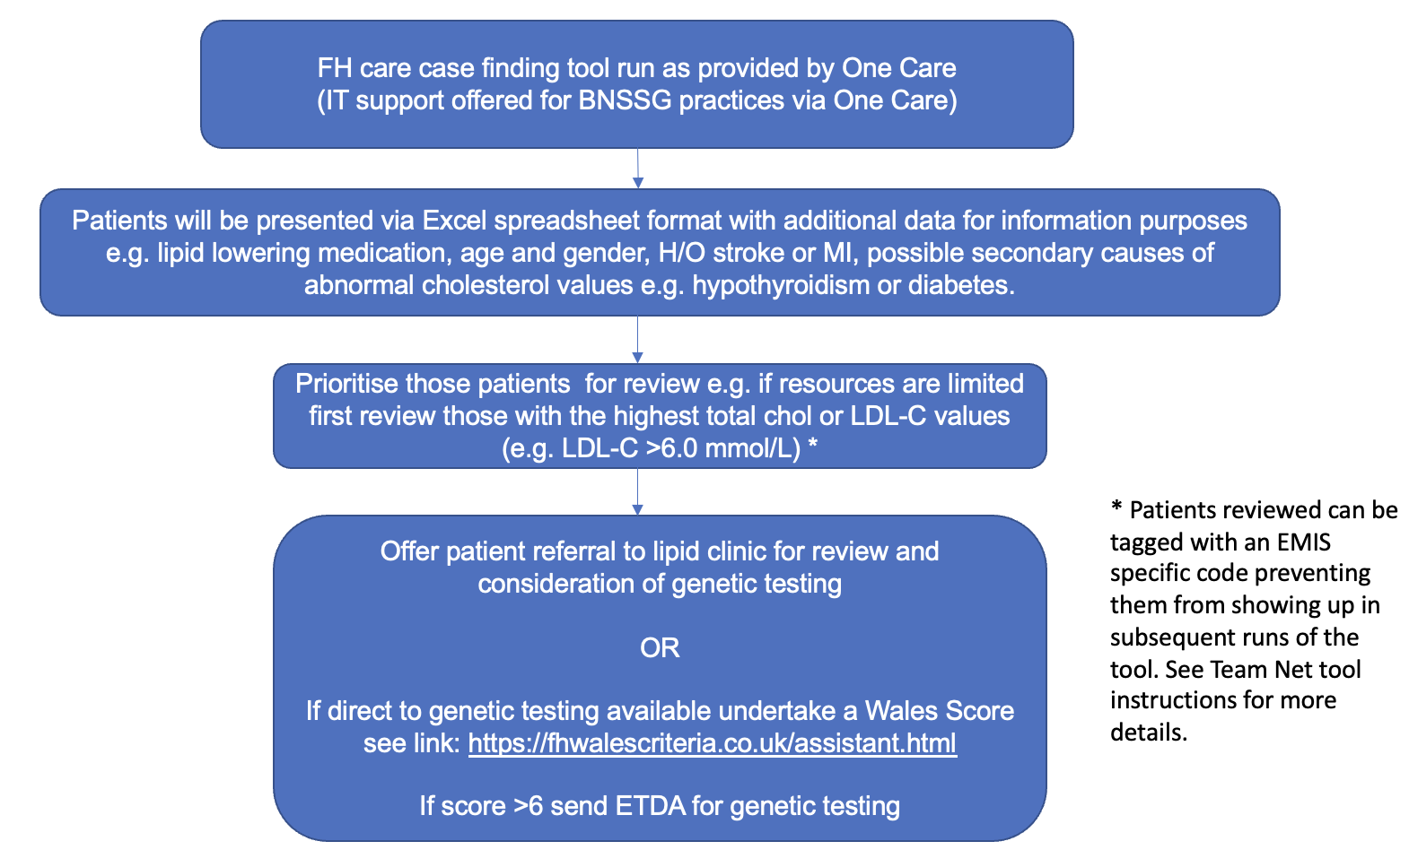

Refer to BNSSG lipid guidance available on REMEDY for onward care and referral following the outcome of the genetic test.

RELATED DOCUMENTS TeamNet - BNSSG FH case finding tool information

QUERIES Dr Paula Rostek, GPwSI in Lipidology, UHBW, paula.rostek@nhs.net
Dr Nathan Cantley, SpR in Chemical Pathology, UHBW, Nathan.cantley@nhs.net
Dr Graham Bayly, Consultant in Clinical Biochemist, UHBW, graham.bayly@UHBristol.nhs.uk
Digital Support Team, One Care, digital@onecare.org.uk

REFERENCES 1. Heart-UK, What is Familial Hypercholesterolaemia?, https://www.heartuk.org.uk/cholesterol/what-is-fh
2. NHS England - The NHS Long term Plan. Published August 2018. https://www.longtermplan.nhs.uk/wp-content/uploads/2019/08/nhs-long-term-plan-version-1.2.pdf
3. Hu P, Dharmayat KI, Stevens CAT, Sharabiani MTA, Jones RS, Watts GF, Genest J, Ray KK, Vallejo-Vaz AJ. Prevalence of Familial Hypercholesterolemia Among the General Population and Patients With Atherosclerotic Cardiovascular Disease: A Systematic Review and Meta-Analysis. Circulation. 2020 Jun 2;141(22):1742-1759. doi: 10.1161/CIRCULATIONAHA.119.044795. Epub 2020 May 29. PMID: 32468833.

