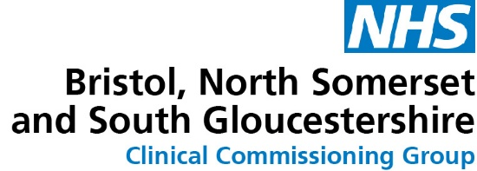

Information about Afghan culture
Understanding Afghani culture and some of the approaches to medicine in Afghanistan is an important part of building trust with the families we are supporting in Bristol.

There are elements of Afghan culture which are different to that of the UK and having an awareness of this will help to build positive relationships with the families and ensure that we are meeting their needs sensitively and respectfully.

Demonstrating an understanding of Afghan culture will also help these families to feel welcome and understood in the UK.

The information below has been provided by Mr. Mujib Khalil, who is a professional translator with Multilingua and a Gynecologist, and has cultural and medical knowledge of Afghanistan. It is intended to provide some basic information for awareness.

Sexual health and relationships in terms of consent and pleasure, sex before marriage, views on/use of contraceptive methods and views on termination of pregnancy

Sex before marriage is rare among Afghan society, and the use of contraceptive is not very common. This is because of low awareness, as well as limited access to contraceptives.

Diet and nutrition – any specific dietary needs or restrictions to be aware of

Most people in Afghan society are Muslim, so availability of Halal food is very important for them, this includes all Halal norms.

Views on mental health and how culturally acceptable is it to talk about this or to accept help in relation to mental health

Talking about mental health is very welcomed by Afghan society and there is no problem at all, Afghans are very friendly and happy to share their mental health problems and talk about them.

What is normal practice re safe sleeping arrangements between parents & their children

Children at adolescent age or over 12 sleep in separate rooms if possible. Young children or infants sleep in the same room with parents. Also depends on economic situation.

Have the children received any newborn hearing screening as this is something that is part of the screening process in England

Newborn hearing screening is not provided in Afghanistan nor is it part of health system packages.

What are the culture views re parenting styles of parents and chastisement? Are they very different to UK?

Yes, they are quite different, punishment in term of physical and mental chastisement is very common.

What are the normal weaning processes in Afghan in comparison to the UK? UK guidance is to introduce weaning foods from six months

This is the same as per ministry of public health guidelines and as Afghanistan is a poor country people cannot afford bottle feeding so weaning is starting by the end of five months.

How to approach the families e.g. how to start a conversation, can we shake people’s hands, what to wear, how to speak to a women if you are a men?

As Afghans are a Muslim community, if you are a man, shaking an Afghan woman’s hand is rude. There is no restriction for you on your clothes and appearance. Also, as long as you are not discussing their religious or culture issues in all other areas you can talk friendly and openly with them.

How to offer sanitary equipment e.g., tampons, condoms

The best way is to offer those supplies is by woman counsellors to Afghan women. Afghan women don’t have a problem talking about these supplies or contraceptive methods as long as the counsellor is a woman.

Any other useful information would be really beneficial

When counsellors, especially women counsellors are talking to Afghan women, there must be privacy in the counselling environment, this will have a great impact.

