January 2024 | Safeguarding Team  NHS BNSSG ICB  Floor 2, North Wing  100 Temple Street  Bristol BS1 6AG  Switchboard 0117 976 6600  bnssg.safeguardingadmin@nhs.net

Dear Practice Managers and GP Safeguarding Leads,

Re: New RCGP Safeguarding Standards for General Practice

In October 2024, the RCGP published the new RCGP safeguarding standards for general practice. These standards are for all GPs and everyone working in a general practice setting in the UK and are an all-age standards incorporating child and adult safeguarding.
The changes to Safeguarding Standards are explored in detail via the RCGP safeguarding toolkit, which everyone can access and work through, via RCGP Safeguarding Hub.
Alongside these new standards the RCGP have developed a new RCGP safeguarding toolkit, Level 3 eLearning module, a podcast and additional resources to support safeguarding learning in general practice.

Key changes to the New RCGP Safeguarding Standards
This section outlines the professional safeguarding training and practice standards for ALL staff working in primary care, including GPs:
- Adults + Children merged into one set of all-age standards
- Competence based, not hours-based training
- Focus on learning and impact on practice
- Focus on general practice being an MDT team
- Engagement with local safeguarding partners and relevant authorities
- Standards arranged into 5 areas of knowledge + capabilities:
  - Responsibilities
  - Identification of abuse and neglect
  - Responding to abuse and neglect
  - Documenting
  - Information sharing and multiagency working

Safeguarding Training
Safeguarding learning is a continual process and enables us to have the knowledge and capabilities to safeguard our patients.
The RCGP Safeguarding Standards set out the professional safeguarding standards and safeguarding training requirements for GPs and anyone working in any general practice setting in the UK. This includes, but is not limited to, NHS GP practices, independent and online providers of general practice services, Primary Care Networks (PCNs), GP out of hours and extended access services. The standards combine and include both safeguarding children and adults and are a whole life course document. These standards form part of the wider intercollegiate documents on safeguarding knowledge and competencies for all healthcare staff.
It is important to note that both adult and child safeguarding knowledge and capabilities are equally necessary and expected for all staff in general practice, even if the staff member only works with adults.
The RCGP Safeguarding Standards set out five key areas of safeguarding knowledge and capabilities, shown here:
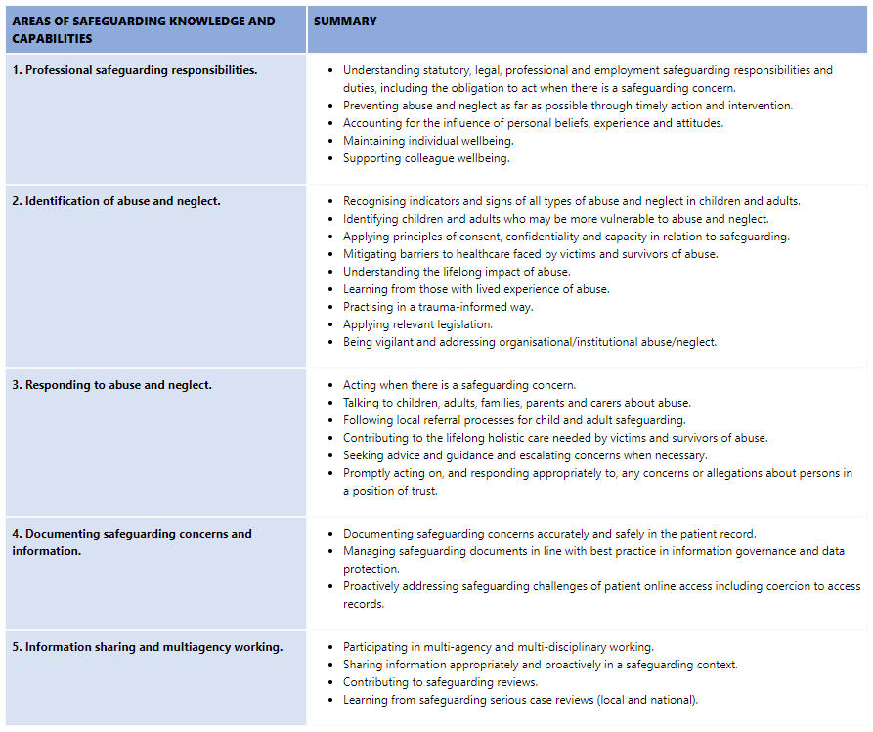
This table gives a summary of the safeguarding training requirements as set out in the RCGP Safeguarding Standards for GPs and anyone working in a general practice setting in the UK:
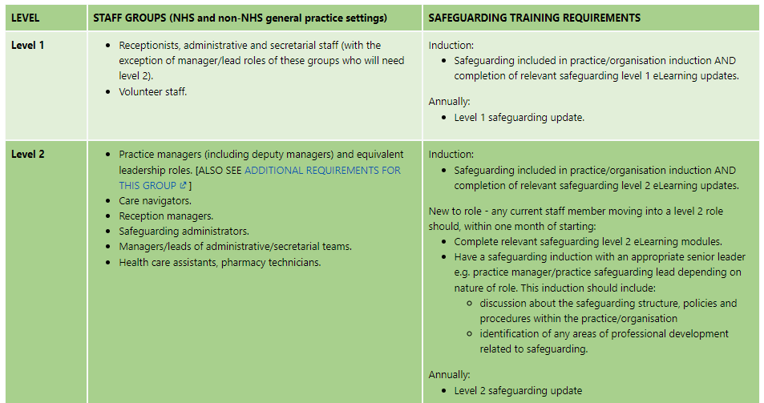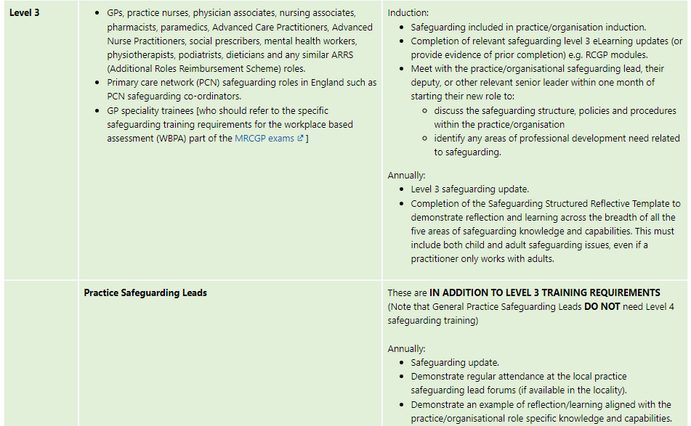
e-Learning: please note the RCGP have produced a new Level 3 module (free to RCGP members, £55 fee for non-members, linked above), however the e-LFH levels 1, 2 and 3 e-learning modules remain available for free: Safeguarding Children and Young People - eLearning for healthcare & Safeguarding Adults - eLearning for healthcare

Level 3: Practitioners should cover both children and adult safeguarding in their learning and reflection, including practitioners who only work with adults.
‘Learning and Reflection’ must be across the five areas of safeguarding knowledge and capabilities, which includes:
Example | How to engage
Safeguarding Case Review | GP Q+A forums / peer supervision  Practice safeguarding meetings
Attendance at a ‘local safeguarding update/course’, with reflection on learning and impact on practice | Link GP meetings  Bitesize webinars  Local Authority training  Level 3 training updates  ICB Safeguarding conference, June 2025
Regular attendance at practice/organisational safeguarding meetings, with reflection on learning and impact on practice | GP Q+A forums / peer supervision  Practice safeguarding meetings
Safeguarding significant events, with reflection on learning and impact on practice | Practice safeguarding meetings
Safeguarding audit/quality improvement activities, with reflection on learning and impact on practice | GP self-assessment audit (available on Remedy from 2025)
Participation in statutory reviews, with reflection on learning and impact on practice | Statutory review learning events (available to practices involved in an CSPR/SAR/DHR)
Multi-agency safeguarding training or learning events, with reflection on learning and impact on practice | Local Authority training  Statutory review learning events
Example of documenting safeguarding concerns and information, and how risks were dealt with
Example of information sharing or involvement in multi-agency working, with reflection on good practice and/or areas for development

RCGP structured templates: These templates have been developed to support documentation of safeguarding learning and reflection. They can be downloaded and used to support annual appraisal and revalidation.
- RCGP Structured Template - Safeguarding Reflective Practice
- RCGP Structured Template - Safeguarding Case Review

BNSSG local resources: Local pathways, guidelines and training updates are available via Remedy
- Adult Safeguarding (Remedy BNSSG ICB)
- Children's Safeguarding (Remedy BNSSG ICB)

BNSSG ICB training opportunities: Local training offer is available via Remedy

Kind regards,
Dr Marie McVeigh & Dr Vicky Donkin - Named GPs for All Age Safeguarding
Louise Ledgerwood-Care & Kirsten Bowes - Named Professionals for Primary Care
ICB Safeguarding Team
Email: bnssg.safeguardingadmin@nhs.net

