**Community/Primary care follow up of COVID-19**

**Background**

The first reports of a novel respiratory virus emerged from Wuhan, China in December 2019, and was subsequently shown to be caused by a coronavirus SARS-CoV-2.1 The virus, which

causes atypical pneumonia progressing to acute lung injury and acute respiratory distress syndrome (ARDS) in some individuals, was named COVID-19 and spread rapidly through other provinces in China. Before long the remainder of the world was affected and on March 11, 2020, WHO assigned to COVID-19 a pandemic status.

Predicting the likely respiratory consequences of COVID-19 is challenging but there may be important parallels from other coronavirus infections; the severe acute respiratory syndrome (SARS) outbreak of 2002-2003 caused by SARS-CoV and that of Middle East respiratory syndrome (MERS).2-6 In a study of SARS survivors, 30% of the entire cohort had persisting CXR abnormalities correlating with abnormalities in lung function testing to suggest that these were physiologically relevant7. Similarly, in MERS survivors, 36% of patients had residual CXR changes at a median of 43 days, the vast majority of which were due to pulmonary fibrosis3.

Early analysis from patients with COVID-19 on discharge suggests a high rate of lung function abnormalities consistent with fibrosis8 and supports the possibility of long term pulmonary fibrosis sequelae in a proportion of these patients.

Initial reports from China9, which were later substantiated by data from Northern Italy10, suggested that the demographic most severely affected by COVID-19 was elderly men, and other poor prognostic factors included a history of smoking and the presence of comorbidities (eg. Hypertension, diabetes mellitus and coronary artery disease). This is a very similar disease demographic to that of idiopathic pulmonary fibrosis – a progressive fibrosing lung condition of unknown cause, whereby viruses have been proposed as a possible triggering factor11. Thus whilst the prevalence of post-COVID-19 fibrosis will only be apparent in time, given the scale of the pandemic, it is unlikely that this will be inconsequential.

COVID-19 also appears to be associated with a hypercoagulable state that causes both arterial and venous thromboembolic complications12 13. The presence of occlusive microthrombi in the small pulmonary vessels of post mortem studies of COVID-19 patients that had died, supports this notion14, and highlights the possibility of pulmonary vascular disease long term sequelae, such as chronic venous thromboembolic disease with or without pulmonary hypertension.

**Routine physical recovery**

Many patients with COVID-19 are asymptomatic or have mild disease and recover quickly over a period of 7- 14 days following variable upper respiratory tract symptoms. However, there will be a proportion of patients who had more severe disease e.g. with pneumonia, thromboembolic disease, myocardial infarction, that may or may not have been admitted to hospital and will have a prolonged recovery time.

The Primary Care Respiratory Society (PCRS) practical guide for clinicians and commissioners, provides a summary of physical, psychosocial and social sequelae of COVID-19, including an anticipated recovery trajectory (www.pcrs-uk.org).

**Usual recovery from Covid-19.** Many people who have COVID-19 are asymptomatic or have mild disease and recover quickly over a period of 7- 14 days with variable upper respiratory tract symptoms.

**4 weeks:** muscle aches, chest pain and sputum production should have substantially reduced (significant sputum production is less common in COVID-19).

**6 weeks:** cough and breathlessness should have substantially reduced.

**3 months:** most symptoms should have resolved but fatigue might still be present.

**6 months:** symptoms should have fully resolved unless the patient has had a complicated ITU stay.

**Patients with more severe disease** (managed in hospital or the community), will likely have a longer recovery particularly if they had additional acute complications or required intensive care.

**Clinical features which might suggest more concerning complications:**

**PE:** breathlessness, pleuritic chest pain

**Pericarditis:** breathlessness, chest pain

**Myocarditis:** breathlessness, chest pain

**Pulmonary fibrosis:** breathlessness, dry cough, inspiratory crepitations on auscultation. Restrictive spirometry (FVC<80%), desaturation on exertion

**Cardiomyopathy:** Persisting breathlessness, ankle swelling

It is usually expected that by:

* 4 weeks — substantial reduction in muscle aches, chest pain and sputum production
* 6 weeks — substantial reduction in cough and breathlessness
* 3 months — most symptoms should have resolved but fatigue might still be present.
* 6 months — symptoms should have fully resolved unless the patient has had a complicated ITU stay, in which case mobility and/or respiratory difficulties may be prolonged.

Those with prolonged intensive care (ICU) stays deserve particular mention as they may have developed profound neuromuscular weakness, including respiratory muscle and other skeletal muscle dysfunction that may take up to a year to recover from.

It is important to recognise that the multisystem nature of this virus means that primary care physicians (PCPs) have a key role to play in identifying patients who may have long term respiratory sequelae of COVID-19 and recognising the need for further evaluation. One of the challenges for PCPs in determining whether a patient may have developed long term respiratory sequelae of COVID-19 infection, is the lack of specificity of symptoms and the unknown true trajectory of disease; thus a high index of suspicion is required in a patient who presents with exertional breathlessness and/or decline in exercise tolerance who describes a recent history of a viral type illness (or confirmed COVID-19) infection, and is not improving in the anticipated trajectory.

PCPs should take a comprehensive medical history in all patients presenting with chronic dyspnoea, including questions about their employment, family and drug history. Assessment for extrapulmonary symptoms, such as fatigue, joint pain and stiffness, may suggest an alternative explanation.

Clinical examination may be normal although an early clinical test that can aid a diagnosis of pulmonary fibrosis is lung auscultation and the presence of inspiratory crackles. Both patients with pulmonary fibrosis or thromboembolic disease may experience oxygen desaturation with only minimal exertion. Whilst spirometry may be normal in the early phases of pulmonary fibrosis, restrictive lung disease tends to be characterised by a reduction in total lung capacity and a normal or elevated FEV1/vital capacity ratio and a reduced FVC, which declines as the disease progresses.

One the most striking findings from a recent prospective follow up study of patients (n=110) admitted with COVID-19 infection to NBT (D. Arnold et al, 2020, In Press), was the persistence of symptoms many weeks after hospitalisation despite normal clinical examination, improved radiological investigations and normal spirometry; 74% patients reported at least one ongoing symptom at 8-12 weeks following diagnosis, the commonest being reported breathlessness, fatigue, myalgia and/or insomnia. Health status scores were reduced compared to population norms with particular deficits in patients perceived ability to perform their physical role and in vitality. These findings stress the importance of a holistic approach to management of these post-COVID patients with a focus on rehabilitation and well-being.

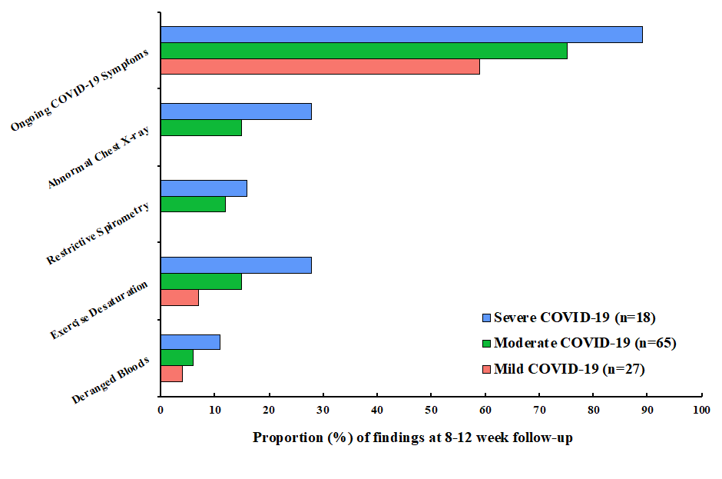

Figure : Summary of symptomatology and clinical results by disease severity (D. Arnold et al. 2020 In Press)

Additionally, findings from a survey of 1225 post COVID-19 patients in the Midlands in May 2020, demonstrated that rehabilitation needs post COVID-19 are complex, due to the multiple co-morbidities that develop. Approximately 75% of pts had between 1 and 6 newly presenting needs requiring rehab post COVID-19. 54.2% of the total need by condition included general fatigue, deconditioning/ muscle atrophy, reduced mobility/falls, reduced function ADL.

There are however varying needs requiring multi-disciplinary inputs as shown below:

Rehabilitation needs by condition;

• 14.4% -↓ mobility /falls

• 14.0% -general fatigue

• 13.4% -↓ function / ADL

• 12.0% -Deconditioning / muscle atrophy

• 9.8% -respiratory including SOB

• 6.8% -nutritional intake

• 5.0% -Depression / anxiety / PTSD

• 3.6% -Dysphagia / swallowing difficulties

The complexity and variability of the damage caused by COVID-19, coupled with the pre-existing disabling long-term conditions that many patients will have, means that there is no single, COVID-19 specific method to determine the need for rehabilitation. Many routine elements of rehabilitation have been paused during the pandemic and requirements for social distancing has meant that group and clinic based services have had to evolve and change to reflect this. There is also no call for separate rehabilitation services to be set up for post COVID-19, rather suggestions that existing pathways should be utilised where possible and the development of key people specialising in the coordination of COVID-19 rehabilitation.

**Investigative pathway**

Please see attached proposed pathway in Appendix A.

This has been formulated through discussion with a small group of clinicians, taking into consideration the British Thoracic Society guidance on post covid follow up.

1. Zhu N, Zhang D, Wang W, et al. A Novel Coronavirus from Patients with Pneumonia in China, 2019. *N Engl J Med.* 2020;382(8):727-733.

2. Das KM, Lee EY, Singh R, et al. Follow-up chest radiographic findings in patients with MERS-CoV after recovery. *Indian J Radiol Imaging.* 2017;27(3):342-349.

3. Das KM, Lee EY, Langer RD, Larsson SG. Middle East Respiratory Syndrome Coronavirus: What Does a Radiologist Need to Know? *AJR Am J Roentgenol.* 2016;206(6):1193-1201.

4. Das KM, Lee EY, Al Jawder SE, et al. Acute Middle East Respiratory Syndrome Coronavirus: Temporal Lung Changes Observed on the Chest Radiographs of 55 Patients. *AJR Am J Roentgenol.* 2015;205(3):W267-274.

5. Ketai L, Paul NS, Wong KT. Radiology of severe acute respiratory syndrome (SARS): the emerging pathologic-radiologic correlates of an emerging disease. *J Thorac Imaging.* 2006;21(4):276-283.

6. Hosseiny M, Kooraki S, Gholamrezanezhad A, Reddy S, Myers L. Radiology Perspective of Coronavirus Disease 2019 (COVID-19): Lessons From Severe Acute Respiratory Syndrome and Middle East Respiratory Syndrome. *AJR Am J Roentgenol.* 2020:1-5.

7. Hui DS, Wong KT, Ko FW, et al. The 1-year impact of severe acute respiratory syndrome on pulmonary function, exercise capacity, and quality of life in a cohort of survivors. *Chest.* 2005;128(4):2247-2261.

8. Mo X, Jian W, Su Z, et al. Abnormal pulmonary function in COVID-19 patients at time of hospital discharge. *Eur Respir J.* 2020.

9. Guan WJ, Ni ZY, Hu Y, et al. Clinical Characteristics of Coronavirus Disease 2019 in China. *N Engl J Med.* 2020;382(18):1708-1720.

10. Livingston E, Bucher K. Coronavirus Disease 2019 (COVID-19) in Italy. *JAMA.* 2020.

11. Sheng G, Chen P, Wei Y, et al. Viral Infection Increases the Risk of Idiopathic Pulmonary Fibrosis: A Meta-Analysis. *Chest.* 2019.

12. Spiezia L, Boscolo A, Poletto F, et al. COVID-19-Related Severe Hypercoagulability in Patients Admitted to Intensive Care Unit for Acute Respiratory Failure. *Thromb Haemost.* 2020;120(6):998-1000.

13. George PM, Wells AU, Jenkins RG. Pulmonary fibrosis and COVID-19: the potential role for antifibrotic therapy. *Lancet Respir Med.* 2020.

14. Lorenzo C, Francesca B, Francesco P, Elena C, Luca S, Paolo S. Acute pulmonary embolism in COVID-19 related hypercoagulability. *J Thromb Thrombolysis.* 2020.

15. Midlands Regional AHP Covid-19 Rehabilitation Needs Survey, NHSE & I, May 2020

16. https://www.rcpjournals.org/content/clinmedicine/early/2020/06/08/clinmed.2020-0353

17. Arnold DT, Hamilton FW, Milne A, Morley A, Viner J, Attwood M, Noel A, Gunning S, Hatrick J, Hamilton S, Elvers KT, Hyams C, Bibby A, Moran E, Adamali H, Dodd J, Maskell NA, Barratt S. Patient outcomes after hospitalisation with COVID-19 and implications for follow-up; results from a prospective UK cohort. 2020 *In Press*

Dr Shaney Barratt / Jen Tomkinson

13th August 2020