**DRY VARICOSE ECZEMA**

**Do you patient’s legs look similar to this?**

**Dry and flaky, scaly or crusty legs?**

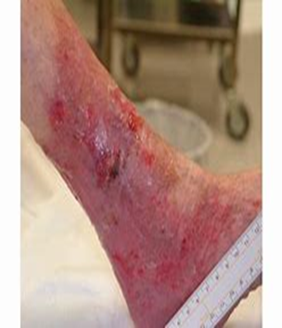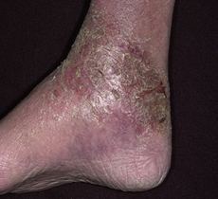

**Dry Varicose Eczema**

* Commence **DAILY** emollient regime for **7 days**.
* **Yes Improvement after 7 days** – Ensure ABPI and assessment for compression therapy has been completed.
* **No Improvement after 7 days** – Commence topical steroid course (Mometasone 0.1% ointment) daily for 7 days. Wean off over 14 days to prevent rebound. Ensure ABPI and assessment for compression therapy has been completed.
* If still no improvement contact the wound care service for further advice.
* Remember to continue with an emollient regime once steroid therapy has been completed. Promote self-care.