**WEEPING ODEMATOUS TOES**

**Do your patient’s toes look like this?**

Before After

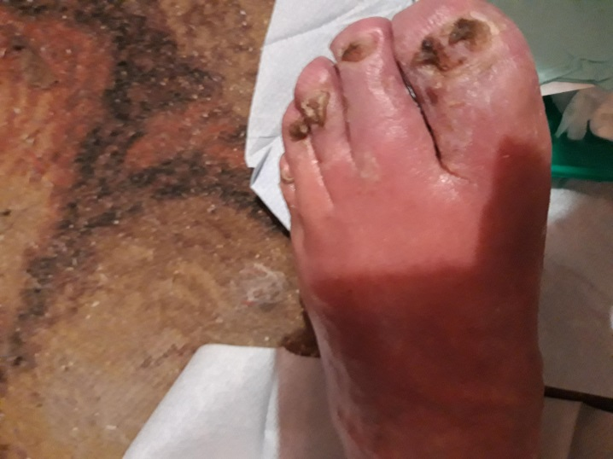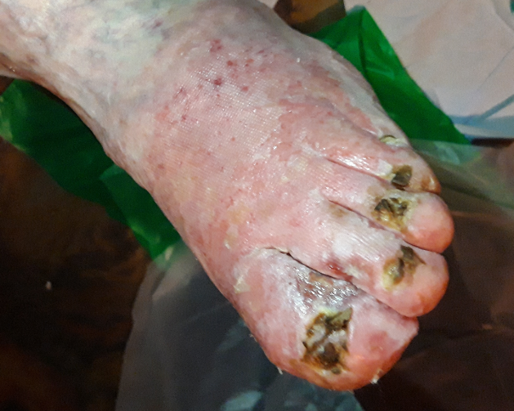

**If yes:**

* Commence use of Octenisan wipes to cleanse between the toes
* Commence Fucibet cream smeared onto atrauman and place between and beneath toes and over forefoot daily for 10 days
* You should see improvement after 3-4 days
* If not add in potassium permanganate soaks prior to the fucibet
* Socks and slippers must be washed to prevent recontamination
* If oedema continues in toes consider measuring for Haddenham toecaps to reduce
* If condition does not resolve refer to podiatry or wound care service