

**Medicine: Diabetes / Endocrinology**

**North Bristol Endocrinology advice for Primary Care**

**Appendix 2**

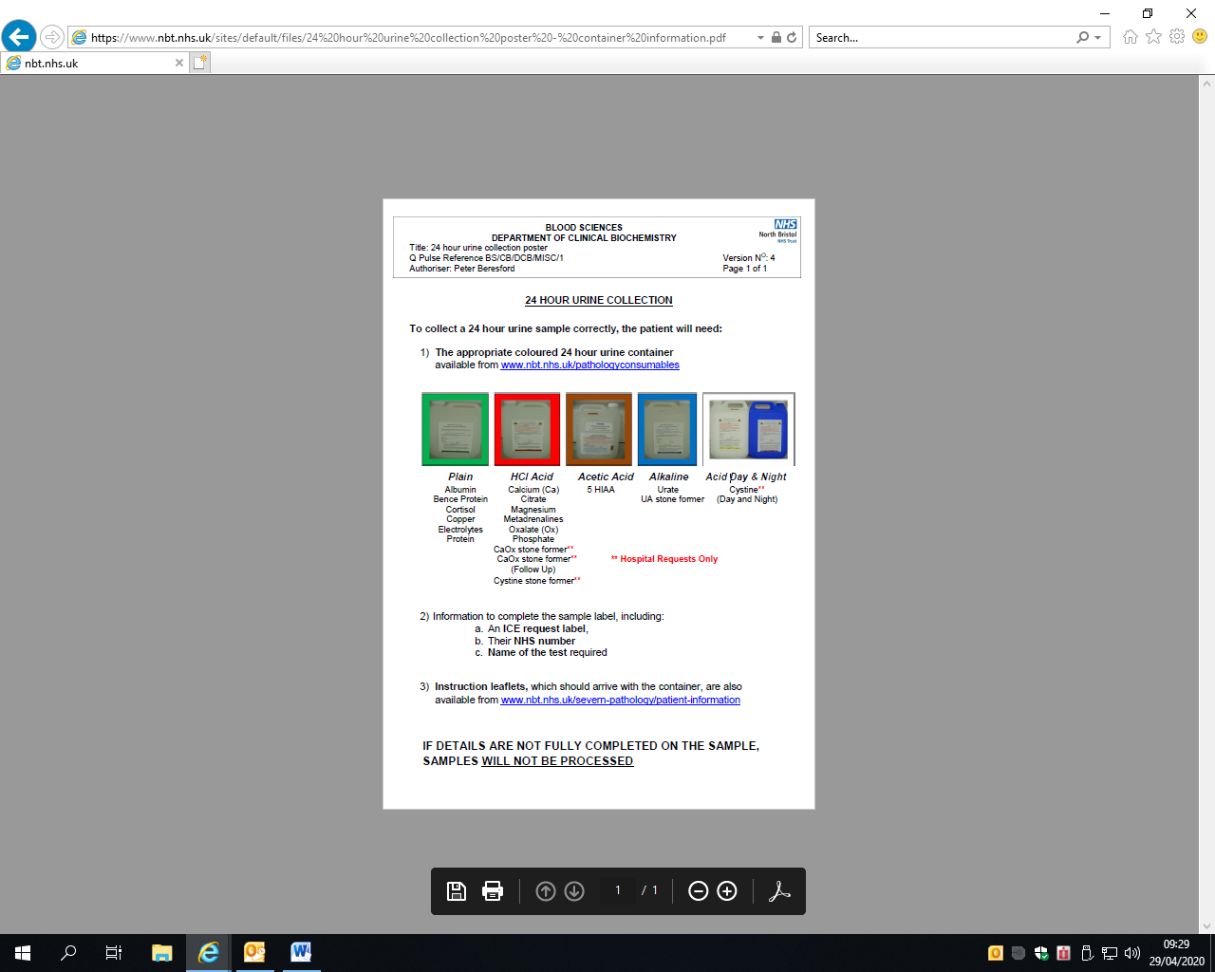

<https://www.nbt.nhs.uk/sites/default/files/24%20hour%20urine%20collection%20poster%20-%20container%20information.pdf>

