**Aspirin to reduce the risk of developing colorectal cancer in adults with Lynch Syndrome.**

1. **What is Lynch Syndrome?**

Lynch Syndrome (LS) is an inherited condition which leads to increased risk of developing certain cancers. LS affects 1 in 350 to 1 in 400 people in the UK. The lifetime risk of developing colorectal cancer in people with LS can be up to 80%. Aspirin has been shown to reduce the risk of developing colorectal cancer in this group of patients.

1. **Benefits of aspirin**

Long-term data from the CAPP2 trial1 shows that aspirin reduces the risk of colorectal cancer by approximately half compared with placebo. Based on these demonstrated benefits, expert consensus is that aspirin should be prescribed for Lynch Syndrome patients2,3,4. A further study (CAPP3) is currently investigating the optimal dose of aspirin in this patient population. Pending publication of CAPP3 results (expected Summer/Autumn 2024), expert consensus suggests dosing detailed in Figure 12,5.

1. **When should aspirin be started and reviewed?**

At this stage there is no evidence to indicate at what age aspirin should be initiated. Until further evidence is available, aspirin should be started as soon as patients are diagnosed with Lynch syndrome.

Aspirin is recommended for a minimum of 2 years’ duration and there is evidence that taking aspirin for up to 5 years is beneficial. 2. There is also evidence to show that the benefits of aspirin continue for several years after it is stopped6.

Patients should have their aspirin dose reviewed at 1 year, or sooner, following publication of results from the CAPP3 study.

1. **Aspirin Treatment**

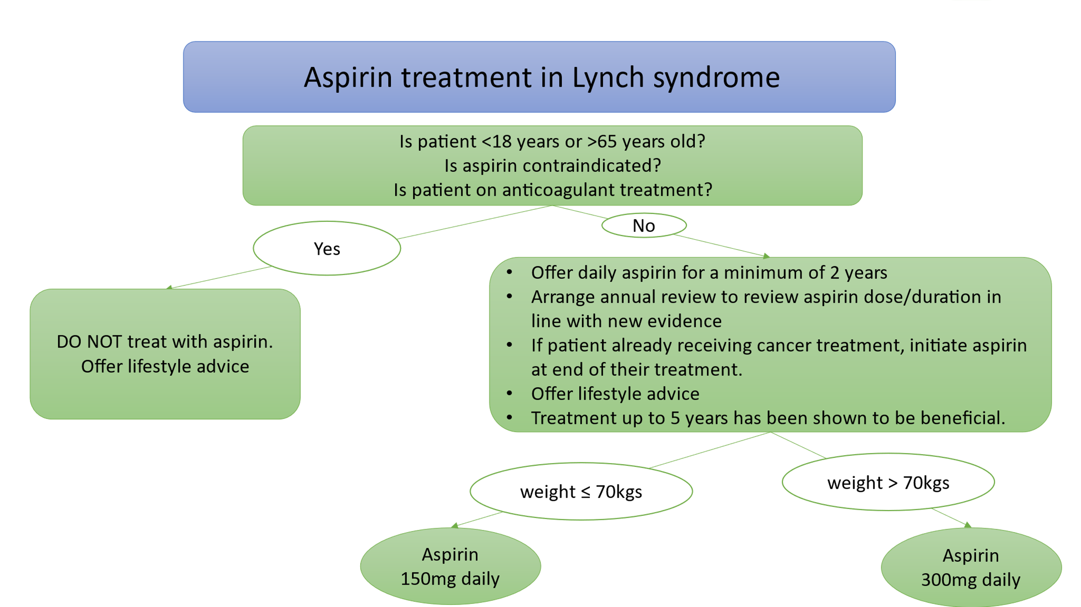

Figure 1. Aspirin dosing recommendations for patients with Lynch Syndrome.

1. **Lifestyle advice**

* Healthy diet – limit red and processed meat consumption and take at least 5 portions of fruit and vegetables a day.
* Maintain a healthy body weight.
* Take regular exercise.
* Avoid alcohol intake.
* Do not to smoke.

1. **Should proton pump inhibitors (PPIs) be prescribed with aspirin?**

* You will need to assess patients on an individual basis and consider PPIs if at higher risk of gastrointestinal (GI) bleed. H.pylori infection increases the risk of gastric cancer in patients with Lynch as well as increasing the risk of bleeding when on aspirin so it is advisable to test and treat for this if positive before the patient starts long term aspirin.2 The risk of bleeding is also higher in older patients and those receiving higher doses of aspirin.

1. **What do I need to check prior to prescribing aspirin?**

* Complete a medication history and check for interactions with other medications and allergies. Remember to check for OTC medications as patient may already be on aspirin.
* If patient already taking OTC aspirin, confirm and document duration of treatment and dose on EMIS medication screen. Optimise treatment (refer to figure 1) and arrange annual follow up.
* Consider bleeding risks including patients with active/recent GI ulcers, recent haemorrhage, GI bleeds.
* Is patient taking other antiplatelets?
* Patients with high blood pressure are at a higher risk of subarachnoid haemorrhage. Check patient’s blood pressure prior to treatment initiation.
* Does the patient have underlying conditions which are likely to be exacerbated by aspirin?

1. **Pregnancy and breastfeeding.**

* The use of aspirin to reduce the risk of colorectal cancer in Lynch is not recommended during pregnancy or breastfeeding. Aspirin can be restarted when the patient is no longer pregnant or breastfeeding.

1. **Why can’t I treat patients who are older than 65 years old?**

* Side effects are likely to be higher in older people with risks outweighing benefits. Overall long-term cancer benefits with aspirin are limited in this age group. This age cut off is based on specialist consensus agreement to avoid aspirin in older patients, based on the results of the ASPREE trial7.

1. **Does Lynch syndrome increase risk of other cancers?**

* Patients with Lynch syndrome have an increased risk of bowel cancer, with women having additional higher risks of gynaecological cancers including endometrial and ovarian cancer. There is also the risk of developing other cancers. Patients presenting with symptoms including unexplained weight loss, changes in bowel habit, abdominal pain, vaginal bleeding, haematuria and skin growths should be referred urgently to their GP.

1. **Useful links for patients**

* [MySunrise - Digital Cancer Support for Better Patient Outcomes](https://www.mysunrise.co.uk/) –
* [NG151 Patient decision aid on Lynch syndrome: should I take aspirin to reduce my chance of getting bowel cancer? (nice.org.uk)](https://gbr01.safelinks.protection.outlook.com/?url=https%3A%2F%2Fwww.nice.org.uk%2Fguidance%2Fng151%2Fresources%2Flynch-syndrome-should-i-take-aspirin-to-reduce-my-chance-of-getting-bowel-cancer-pdf-8834927869&data=05%7C02%7Chelen.mcclay1%40nhs.net%7Cad84a0a397c44778398808dc23091b87%7C37c354b285b047f5b22207b48d774ee3%7C0%7C0%7C638423769264296793%7CUnknown%7CTWFpbGZsb3d8eyJWIjoiMC4wLjAwMDAiLCJQIjoiV2luMzIiLCJBTiI6Ik1haWwiLCJXVCI6Mn0%3D%7C0%7C%7C%7C&sdata=6TcUnM9FodbAlVyJ7eB6Jxccv0lRGnVw9mQgCZ6eH0o%3D&reserved=0)
* [Bowel Cancer | Lynch Syndrome UK (lynch-syndrome-uk.org)](https://www.lynch-syndrome-uk.org/)
* [Helping you decide leaflet - GOV.UK (www.gov.uk)](https://www.gov.uk/government/publications/lynch-syndrome/helping-you-decide-leaflet)

1. **References**
2. Burn J, Gerdes A-M, Macrae F, et al. Long-term effect of aspirin on cancer risk in carriers of hereditary colorectal cancer: an analysis from the CAPP2 randomised controlled trial. Lancet 2011;378:2081–7.
3. Edwards P, Monahan K. Diagnosis and management of Lynch syndrome. Frontline Gastroenterology 2022;13:e80–e87. <https://fg.bmj.com/content/flgastro/13/e1/e80.full.pdf>
4. NICE 2020. Lynch syndrome: should I take aspirin to reduce my chance of getting bowel cancer? Patient decision aid: user guide and data sources. <https://www.nice.org.uk/guidance/ng151/resources/lynch-syndrome-should-i-take-aspirin-to-reduce-my-chance-of-getting-bowel-cancer-pdf-8834927869>
5. Seppa T, Latchford A, Negoi I et al. European guidelines from the EHTG and ESCP for Lynch syndrome: an updated third edition of the Mallorca guidelines based on gene and gender. Br J Surg 2021 May 27;108(5):484-498. <https://www.ncbi.nlm.nih.gov/pmc/articles/PMC10364896/pdf/znaa178.pdf>
6. UK Cancer Genetics Group Leaflets and Guidelines. Lynch Syndrome <https://www.ukcgg.org/information-education/ukcgg-leaflets-and-guidelines/> [Accessed 22/02/2024]
7. Burn J, Sheth H, Elliott F, Reed L, Macrae F, Mecklin JP et al.; CAPP2 Investigators. Cancer prevention with aspirin in hereditary colorectal cancer (Lynch syndrome), 10-year follow-up and registry-based 20-year data in the CAPP2 study: a double-blind,randomised, placebo-controlled trial. Lancet 2020; 395:1855–1863.
8. McNeil J, Nelson M, Woods R et al. Effect of Aspirin on All-Cause Mortality in the Healthy Elderly N Engl J Med 2018; 379:1519-152 <https://www.nejm.org/doi/full/10.1056/NEJMoa1803955>
9. **Support resources for pharmacists**

* NHS England. Genomics Education Programme, GeNotes. Lynch Syndrome. [Lynch syndrome — Knowledge Hub (hee.nhs.uk)](https://www.genomicseducation.hee.nhs.uk/genotes/knowledge-hub/lynch-syndrome/)
* NICE 2021. Colorectal Cancer (NG151) <https://www.nice.org.uk/guidance/ng151/resources/colorectal-cancer-pdf-66141835244485>
* UK Cancer Genetics Group Leaflets and Guidelines. Lynch Syndrome [UKCGG leaflets and guidelines - Cancer Genetics Group](https://www.ukcgg.org/information-education/ukcgg-leaflets-and-guidelines/)